NAME: Oyindamola Obisesan   
STUDENT ID: 113511813

EMAIL: OYIN.OBISESAN@OU.EDU  
COURSE: CS/DSA 4513 – DATABASE MANAGEMENT

SECTION: 995  
SECTION: ONLINE   
SEMESTER: FALL 2021   
INSTRUCTOR: DR. LE GRUENWALD

INDIVIDUAL PROJECT  
SCORE:

# Task 1

## ER Diagram

|  |
| --- |
|  Relational Database Customer (cust_Name, address, category) |
| Assembly (assm_id, pid, cust_name, date_assm, detail) |
| Order (cust_name, assm_id) |
| Has (assm_id, pid) |
| Processes (pid, dept_num, data) |
| processes_fit (pid, dept_num, type) |
| processes_paint (pid, dept_num, type, method) |
| processes_cut (pid, dept_num, type, machine_type) |
| job_cut (job_id, type_of_machine, amount_of_time, materials_used, labor_time_cut, date_start, date_end) |
| job_paint (job_id, color, volume, labor_time_paint, date_start, date_end) |
| job_fit (job_id, labor_time_fit, date_start, date_end) |
| department (dep_num, data) |
| acct_assem (acct_num, assm_id, date_est, cost_assm) |
| acct_dep (acct_num, dep_num, date_est, cost_dep) |
| acct_pro (acct_num, pid, date_est, cost_pro) |
| transactions (trans_id, sub_cost) |
| update (acct_num, trans_id) |
| record (trans_id, job_id)  done (job_id, pid, dep_num) Task 2 - Data Dictionary |

|  |  |  |  |
| --- | --- | --- | --- |
| P/F | Field Name | Types | Size |
| Customer | Cust_name  Address  category | Varchar  Varchar  Numeric/integer | 30  40  2 |
| Assembly | Assm_ID  Date_assem  details | Varchar  Date  bit | 12  3  64 |
| Process | Pid  Process_data  Dept_num | Varchar  Varchar  integer | 12  30  2,2 |
| Process_fit | Pid  Fit_type  Dept_num | Varchar  Varchar  int | 12  12  3 |
| Process_ Paint | pid  paint_Type  paint_method  dept_num | Varchar  Varchar  Varchar  Int | 12  12  12  2 |
| Process_cut | pid  cut_Type  Machine-type  Dept_num | Varchar  Varchar  Varchar  Int | 12  12  12  2 |
| Job_ Cut | Job_id  type_machine amount_of_time material_used labor_time_cut  date_start  date_end | Integer  Varchar  Numeric  Varchar  Numeric  Date  Date | 2,2  15  3  30  3  3  3 |
| job _ Paint | Job_id  Color  Volume  Labor_time_paint  Date_start  Date_end | Integer  Varchar  Numeric  Numeric  date  date | 5  12  3  3  3  3 |
| Job_fit | Jobid  labor_time_fit  date_start  date_end | Integer  Numeric  Date  Date | 20  3  3  3 |
| department | Dept_num  Dep_data | Integer  varchar | 2  30 |
| Acct_assem | Acct_num  Cost_assm  Date_est  Assm_id | Integer  Numeric  Date  Varchar | 10  10  3  12 |
| Department_acct | Acct_num  Dep_num  Cost_dep  Date_est | Int  Int  Numeric  Date | 10  2  10  3 |
| Acct_pro | Acct_num  pid  Cost_pro  Date_est | int  varchar  numeric  date | 10  12  10  3 |
| transaction | Trans_id  Sub_cost | Varchar  Numeric | 15  10 |
| has | Assm_id  pid | Varchar  varchar | 12  12 |
| order | Cust_name  Assm_id | Varchar  varchar | 12  12 |
| update | Acct_num  Trans_id | Int  varchar | 10  15 |
| record | Trans_id  Job_id | Varchar  int | 15  10 |
| done | Job_id  Dep_num  pid | Int  Int  varchar | 10  2  12 |

# Task 3

## 3.1. Discussion of storage structures

|  |  |  |  |  |  |
| --- | --- | --- | --- | --- | --- |
| Table Name | Query # and Type | Search Key | Query Frequency | Selected File Organization | Justification |
| Customer | 1, insert  13, range search | category | 30/day  100/day | Extendable Hashing on category | The hash function can be the category number since they are only 10. They can be searched in each of the bucket. |
| department | 2, insert  12, random search | Dep_num | Infrequent  20/day | Index sequential file on dep_num | Since this is not done very frequently, the file can be arranged in sequential order with the dep_num and searched. |
| processes | 3, insert |  | infrequent | Primary indexing on pid | Since this is not done very frequently, the file can be arranged in sequential order with the pid and searched. |
| Processes_cut | 3, insert |  | infrequent | Primary indexing on pid | Since this is not done very frequently, the file can be arranged in sequential order with the pid and searched. |
| Processes_fit | 3, insert |  | infrequent | Primary indexing on pid | Since this is not done very frequently, the file can be arranged in sequential order with the pid and searched. |
| Processes_paint | 3, insert |  | infrequent | Primary indexing on pid | Since this is not done very frequently, the file can be arranged in sequential order with the pid and searched. |
| Acct_assem | 5, insert  8, random search  9, random search | Acct_num  Assm_id | 10/day  50/day  200/day | Index sequential file  primary index on assm_id  secondary index on acct_num | The primary search is done on assm_id because it occurs more frequently |
| acct_dep | (or 5, insert)  8, random search | Acct_num | 10/day  50/day | Index sequential file  primary index on assm_id  secondary index on acct_num | The primary search is done on assm_id because it occurs more frequently |
| acct_pro | (or 5, insert)  8, random search | Acct_num | 10/day  50/day | Index sequential file  primary index on assm_id  secondary index on acct_num | The primary search is done on assm_id because it occurs more frequently |
| assemblies | 4, insert  11, random search | Assm_id | 100/day | Extendable hashing on assm_id | This occurs frequently and needs to be accessed fast. |
| orders | 4, insert |  | 40/day | heap |  |
| has | 4, insert  6, insert |  | 40/day  50/day | Index sequential |  |
| done | 6, insert  10, random search | Dep_num | 50/day  20/day | Index sequential on dept_num | The search is infrequent |
|  |  |  |  |  |  |
| job_cut | 6, insert  7, update  10, random search  12, random search  14, deletion | Job_id  Date_end  Date_end  Job_id | 50/day  50/day  20/day  20/day  1/month | Index sequential file  Primary index on job_id  And secondary index on date_end | The search is done on job_id because it occurs more frequently than date_end |
| transactions | 8, insert |  | 40/day | Sequential primary index on trans_id |  |
| Job_fit | (or 6, insert)  7, update  10, random search  12, random search | Job_id  Date_end  Date_end | 50/day  50/day  20/day  20/day | Index sequential file  Primary index on job_id  And secondary index on date_end | The search is done on job_id because it occurs more frequently than date_end |
| Job_paint | (or 6, insert)  7, update  10, random search  12, random search  15, update | Job_id  Date_end  Date_end  Jod_id | 50/day  50/day  20/day  20/day  1/week | Index sequential file  Primary index on job_id  And secondary index on date_end | The search is done on job_id because it occurs more frequently than date_end |

## 3.2. Discussion of storage structures (Azure SQL Database)

The index sequential search was the database selected for use on this database. The primary key creates the index automatically. A secondary key is selected based on the other attributes that the queries search.

create NONCLUSTERED index customer on dbo.customer(category)

create NONCLUSTERED index done on dbo.done(dep_num)

create NONCLUSTERED index job_fit on dbo.job_fit(date_end)

create NONCLUSTERED index job_cut on dbo.job_cut(date_end)

create NONCLUSTERED index job_paint on dbo.job_paint(date_end)

# Task 4 - SQL statements and screenshots showing the creation of tables in Azure SQL Database

**Table Creation**

drop table if exists records

drop table if exists orders

drop table if exists processes

drop table if exists processes_fit

drop table if exists processes_paint

drop table if exists processes_cut

drop table if exists has

drop table if exists job_cut

drop table if exists job_paint

drop table if exists job_fit

drop table if exists acct_assem

drop table if exists acct_dep

drop table if exists acct_pro

drop table if exists updates

drop table if exists records

drop table if exists transactions

drop table if exists done

drop table if exists department

drop table if exists assemblies

drop table if exists customer

create table customer(

cust_name varchar(30) primary key,

addr varchar(30),

category integer

);

create table assemblies(

assm_id varchar(12),

pid varchar(12),

cust_name varchar(30) foreign key references customer (cust_name),

dat_assm date,

detail varchar(40),

primary key (assm_id, pid, cust_name)

);

create table orders(

--assm_id varchar(12) foreign key references assemblies (assm_id),

assm_id varchar(12),

cust_name varchar(30) foreign key references customer (cust_name),

primary key (cust_name, assm_id)

);

create table has(

--assm_id varchar(12) foreign key references assemblies (assm_id),

assm_id varchar(12),

pid varchar(12),

--job_id integer,

primary key (assm_id, pid)

);

create table department(

dept_num integer primary key,

dep_data varchar(30)

);

create table processes(

pid varchar(12),

process_data varchar(30),

--assm_id varchar(12) foreign key references assemblies(assm_id),

--assm_id varchar(12),

dept_num integer foreign key references department(dept_num),

primary key (pid, dept_num)

);

create table processes_fit(

pid varchar(12),

fit_type varchar(12),

--assm_id varchar(12) foreign key references assemblies(assm_id),

--assm_id varchar(12),

dept_num integer foreign key references department(dept_num),

primary key (pid, dept_num)

);

create table processes_paint(

pid varchar(12),

paint_type varchar(12),

paint_method varchar(20),

dept_num integer foreign key references department(dept_num),

primary key (pid, dept_num)

);

create table processes_cut(

pid varchar(12),

cut_type varchar(12),

machine_type varchar (12),

dept_num integer foreign key references department(dept_num),

primary key (pid, dept_num)

);

create table job_cut(

job_id integer primary key,

type_of_mac varchar(15),

amt_time numeric,

mat_used varchar(30),

labor_time_cut numeric,

date_start date,

date_end date

);

create table job_paint(

job_id integer primary key,

color varchar(12),

volume numeric,

labor_time_paint numeric,

date_start date,

date_end date

);

create table job_fit(

job_id integer primary key,

labor_time_fit numeric,

date_start date,

date_end date

);

create table acct_assem(

acct_num integer,

assm_id varchar(12),

date_est date,

cost_assm numeric,

primary key(acct_num, assm_id)

);

create table acct_dep(

acct_num integer,

dept_num integer foreign key references department (dept_num),

date_est date,

cost_dept numeric

primary key (acct_num, dept_num)

);

create table acct_pro(

pid varchar(12),

acct_num integer,

date_est date,

cost_pro numeric,

primary key (acct_num, pid)

);

create table transactions(

trans_id varchar(15) primary key,

sub_cost numeric

);

create table updates(

acct_num integer,

trans_id varchar(15) foreign key references transactions(trans_id),

primary key (acct_num, trans_id)

);

create table records(

trans_id varchar(15) foreign key references transactions(trans_id),

job_id integer,

primary key (trans_id, job_id)

);

create table done(

dep_num integer foreign key references department (dept_num),

pid varchar(12),

job_id integer

primary key (job_id,pid, dep_num)

);

# Task 5

## 5.1. SQL statements and T-SQL implementing queries 1-15

### 5.1.1. SQL

--1

insert into customer

values

('Oyindamola', '2900 Beaumont', 2),

--2

insert into department

values

(7, 'this is Mewbourne');

--3

insert into department

values

(9, 'DSA');

insert into processes

values

('40', 9, 'process?')

update processes_fit

set fit_type = 'straight'

where pid = '40'

--4

insert into assemblies

values

('78', '67', 'Kome', '23-05-2021', 'assembly')

insert into orders

values

('Kome', '78')

insert into has

values

('78', '67')

--5

insert into acct_assem

values

(2333455, '6', '2021-04-04', 567)

--6

insert into job_fit(job_id, date_start)

values

(56, '2021-04-05');

insert into done

values

(34, '45', 56)

insert has

values

('67', '56')

--7

update job_fit

set

date_end = '2021-04-06',

labor_time_fit = 5

where job_id = 56

--8

insert into transactions

values

(345, 45)

--9

select sum (cost_assm)

from acct_assem

where assm_id = 34

--10

select sum (total_labor) from (

select sum(labor_time_cut) as total_labor from job_cut where job_id in (select job_id from done where dept_num = 2) and date_end = '2021-04-03' union all

select sum(labor_time_cut) as total_labor from job_fit where job_id in (select job_id from done where dept_num = 2) and date_end = '2021-04-03' union all

select sum(labor_time_cut) as total_labor from job_paint where job_id in (select job_id from done where dept_num = 2) and date_end = '2021-04-03'

) total_labor_time

--x group by dep_num

--11

select done.job_id, dept_num

from assemblies

inner join

done on assemblies.pid = done.pid

right join

(select job_id, date_start, date_end

from job_cut

UNION

select job_id, date_start, date_end

from job_paint

UNION

select job_id, date_start, date_end

from job_fit) aa

on done.job_id = aa.job_id

where assm_id = 45

order by date_start

--12a

select *

from assemblies

inner join

done on assemblies.pid = done.pid

right join

job_cut on done.job_id = job_cut.job_id

--12b

select *

from assemblies

inner join

done on assemblies.pid = done.pid

right join

job_fit on done.job_id = job_fit.job_id

--12c

select *

from assemblies

inner join

done on assemblies.pid = done.pid

right join

job_paint on done.job_id = job_paint.job_id

--13

select cust_name

from customer

where category between 4 and 5

order by cust_name asc

-- 14

delete

from job_cut

where job_id between 40 and 60

--15

update job_paint

set color = 'red'

where job_id = 56

### 5.1.2. T-SQL

drop procedure query1

go

create PROCEDURE query1

@cust_name varchar(30),

@addr varchar(30),

@category integer

as

BEGIN

insert into customer (cust_name, addr, category)

values (@cust_name, @addr, @category)

end

drop procedure query2

go

create PROCEDURE query2

@dept_num integer,

@dep_data varchar(30)

as

BEGIN

insert into department (dept_num, dep_data)

values (@dept_num, @dep_data)

end

drop procedure query3

go

create procedure query3

@pid varchar(12),

@process_data varchar(30),

@dept_num integer,

@type_process varchar(30),

@cut_type varchar(30),

@machine_type VARCHAR(30),

@fit_type VARCHAR(30),

@paint_type varchar(30),

@paint_method varchar(30)

as

BEGIN

--insert department (dept_num)

--values (@dept_num)

INSERT processes (pid, process_data, dept_num)

values (@pid, @process_data, @dept_num)

if @type_process = 'cut'

insert into processes_cut (pid, cut_type, machine_type, dept_num)

values (@pid, @cut_type, @machine_type, @dept_num)

if @type_process = 'fit'

insert into processes_fit (pid, fit_type, dept_num)

values (@pid, @fit_type, @dept_num)

if @type_process = 'paint'

insert into processes_paint (pid, paint_type, paint_method, dept_num)

values (@pid, @paint_type, @paint_method, @dept_num)

end

drop PROCEDURE query4

go

CREATE procedure query4

@assm_id varchar(12),

@pid integer,

@cust_name varchar(30),

@dat_assm date,

@detail varchar(30),

@dep_num INTEGER,

@job_id integer

as

begin

--insert customer (cust_name)

--values (@cust_name)

insert into assemblies (assm_id, pid, cust_name, dat_assm, detail)

values (@assm_id, @pid, @cust_name, @dat_assm, @detail)

insert orders (assm_id, cust_name)

values (@assm_id, @cust_name)

insert into has (assm_id, pid)

values (@assm_id, @pid)

end

drop procedure query5

go

create procedure query5

@acct_num integer,

@pid varchar(12),

@assm_id varchar(12),

@date_est date,

@dept_num integer,

@type_acct varchar(12),

@cost_assm numeric,

@cost_dept numeric,

@cost_pro numeric

as

begin

if (@type_acct = 'assembly')

begin

insert into acct_assem (acct_num, assm_id, date_est, cost_assm)

values (@acct_num, @assm_id, @date_est, @cost_assm)

end

if (@type_acct = 'department')

begin

insert into acct_dep (acct_num, dept_num, date_est, cost_dept)

values (@acct_num, @dept_num, @date_est, @cost_dept)

end

if (@type_acct = 'process')

begin

insert into acct_pro (pid, acct_num, date_est, cost_pro)

values (@pid, @acct_num, @date_est, @cost_pro)

end

end

drop procedure query6

GO

create procedure query6

@job_id INTEGER,

@date_start date,

@dept_num integer,

@pid varchar(12),

@assm_id varchar(12),

@type_job varchar (12)

as

begin

--INSERT into job_fit (job_id, date_start)

--values (@job_id, @date_start)

--insert into department(dept_num)

--values (@dept_num)

insert into done (dep_num, pid, job_id)

values (@dept_num, @pid, @job_id)

insert into has (assm_id, pid)

values (@assm_id, @pid)

if @type_job = 'fit'

INSERT into job_fit (job_id, date_start)

values (@job_id, @date_start)

if @type_job = 'cut'

insert into job_cut (job_id, date_start)

values (@job_id, @date_start)

if @type_job = 'paint'

insert into job_paint (job_id, date_start)

values (@job_id, @date_start)

end

drop procedure query7

go

create procedure query7

@date_end date,

@labor_time_cut numeric,

@labor_time_fit numeric,

@labor_time_paint numeric,

@job_id integer,

@type_job varchar(12),

@type_of_mac varchar(15),

@amt_time numeric,

@mat_used varchar(30),

@volume numeric,

@color varchar(12)

as

BEGIN

begin

update job_cut

set

date_end = @date_end,

labor_time_cut = @labor_time_cut,

type_of_mac = @type_of_mac,

amt_time = @amt_time,

mat_used = @mat_used

where job_id = @job_id and @type_job = 'cut'

end

begin

update job_fit

set

date_end = @date_end,

labor_time_fit = @labor_time_fit

where job_id = @job_id and @type_job = 'fit'

end

begin

update job_paint

set

date_end = @date_end,

labor_time_paint = @labor_time_paint,

volume = @volume,

color = @color

where job_id = @job_id and @type_job = 'paint'

end

END

drop procedure query8

go

create procedure query8

@trans_id varchar(15),

@sub_cost numeric,

@acct_type varchar(15),

@assm_id varchar(15),

@acct_num integer,

@date_est date

as

begin

insert into transactions (trans_id, sub_cost)

values (@trans_id, @sub_cost)

end

begin

update acct_assem

set

cost_assm = cost_assm + @sub_cost,

date_est = @date_est

where acct_num = @acct_num and @acct_type = 'assembly'

end

begin

update acct_dep

set

cost_dept = cost_dept + @sub_cost,

date_est = @date_est

where acct_num = @acct_num and @acct_type = 'department'

end

begin

update acct_pro

set

cost_pro = cost_pro + @sub_cost,

date_est = @date_est

where acct_num = @acct_num and @acct_type = 'assembly'

end

drop PROCEDURE query9

go

create procedure query9

@assm_id varchar (12)

as

begin

select sum (cost_assm) as total_cost

from acct_assem

where assm_id = @assm_id

end

drop procedure query10

GO

create procedure query10

@dept_num integer,

@date_end date

as

begin

select sum (total_labor) from (

select sum(labor_time_cut) as total_labor from job_cut where job_id in (select job_id from done where dep_num = @dept_num) and date_end = @date_end union all

select sum(labor_time_fit) as total_labor from job_fit where job_id in (select job_id from done where dep_num = @dept_num) and date_end = @date_end union all

select sum(labor_time_paint) as total_labor from job_paint where job_id in (select job_id from done where dep_num = @dept_num) and date_end = @date_end

) total_labor_time

end

drop procedure query11

GO

create procedure query11

@assm_id varchar(12)

as

begin

select done.job_id, dep_num

from assemblies

inner join

done on assemblies.pid = done.pid

right join

(select job_id, date_start, date_end

from job_cut

UNION

select job_id, date_start, date_end

from job_paint

UNION

select job_id, date_start, date_end

from job_fit) aa

on done.job_id = aa.job_id

where assm_id = @assm_id

order by date_start

end

drop procedure query12

GO

create PROCEDURE query12

@job_type varchar(12),

@date_end date,

@dept_num integer

as

begin

if @job_type = 'cut'

select *

from assemblies

inner join

done on assemblies.pid = done.pid

right join

job_cut on done.job_id = job_cut.job_id

where date_end = @date_end and dep_num = @dept_num

if @job_type = 'fit'

select *

from assemblies

inner join

done on assemblies.pid = done.pid

right join

job_fit on done.job_id = job_fit.job_id

where date_end = @date_end and dep_num = @dept_num

if @job_type = 'paint'

select *

from assemblies

inner join

done on assemblies.pid = done.pid

right join

job_paint on done.job_id = job_paint.job_id

where date_end = @date_end and dep_num = @dept_num

end

go

create procedure query13

@cat_1 integer,

@cat_2 integer

as

BEGIN

select cust_name

from customer

where category between @cat_1 and @cat_2

order by cust_name asc

end

go

create procedure query14

@job_id_1 integer,

@job_id_2 INTEGER

as

begin

delete

from job_cut

where job_id between @job_id_1 and @job_id_2

end

go

create procedure query15

@job_id integer,

@color varchar(15)

as

begin

update job_paint

set color = @color

where job_id = @job_id

end

drop procedure query16

go

create procedure query16

@cust_name varchar (30),

@addr varchar(30),

@category integer

as

begin

insert into customer

values(@cust_name, @addr, @category)

end

drop procedure query17

go

create procedure query17

@cat_1 integer,

@cat_2 integer

as

begin

select cust_name

from customer

where category between @cat_1 and @cat_2

order by cust_name asc

end

## 5.2. Java Source Program and Screenshots

### 5.2.1. Java Source Program

import java.sql.Connection;

import java.sql.Statement;

import java.util.Scanner;

import java.sql.ResultSet;

import java.sql.SQLException;

import java.sql.DriverManager;

import java.sql.PreparedStatement;

import java.io.IOException;

import java.io.File;

import java.io.FileWriter;

import java.io.FileNotFoundException;

public class Project1 {

// Database credentials

final static String HOSTNAME = "obis000-sql-server.database.windows.net";

final static String DBNAME = "cs-dsa-4513-sql-db";

final static String USERNAME = "obis0000";

final static String PASSWORD = "Anec3030";

// Database connection string

final static String URL = String.format("jdbc:sqlserver://%s:1433;database=%s;user=%s;password=%s;encrypt=true;trustServerCertificate=false;hostNameInCertificate=*.database.windows.net;loginTimeout=30;",

HOSTNAME, DBNAME, USERNAME, PASSWORD);

// Query templates

final static String QUERY_TEMPLATE_1 = "EXEC query1 @cust_name = ?, @addr = ?, @category = ?;";

final static String QUERY_TEMPLATE_2 = "EXEC query2 @dept_num = ?, @dep_data = ?;";

final static String QUERY_TEMPLATE_3 = "EXEC query3 @pid = ?, @process_data = ?, @dept_num = ?, @type_process = ?, @cut_type = ?, @machine_type = ?, @fit_type = ?, @paint_type = ?, @paint_method = ?;";

//final static String QUERY_TEMPLATE_3 = "EXEC query3 @pid = ?, @process_data = ?, @dept_num = ?, @type_process = ?, @cut_type = ?, machine_type = ?, @fit_type = ?, @paint_type = ?, @paint_method = ?;";

final static String QUERY_TEMPLATE_4 = "EXEC query4 @assm_id = ?, @pid = ?, @cust_name = ?, @dat_assm = ?, @detail = ?, @job_id = ?, @dep_num = ?;";

final static String QUERY_TEMPLATE_5 = "EXEC query5 @acct_num = ?, @pid = ?, @assm_id = ?, @date_est = ?, @dept_num = ?, @type_acct = ?, @cost_assm = ?, @cost_dept = ?, @cost_pro = ?;";

final static String QUERY_TEMPLATE_6 = "EXEC query6 @job_id = ?, @date_start = ?, @dept_num = ?, @pid = ?, @assm_id = ?, @type_job = ?;";

final static String QUERY_TEMPLATE_7 = "EXEC query7 @date_end = ?, @labor_time_cut = ?, @labor_time_fit = ?, @labor_time_paint = ?, @job_id = ?, @type_job = ?, @type_of_mac = ?, @amt_time = ?, @mat_used = ?, @volume = ?, @color = ?;";

final static String QUERY_TEMPLATE_8 = "EXEC query8 @trans_id = ?, @sub_cost = ?, @acct_type = ?, @assm_id = ?, @acct_num = ?, @date_est = ?;";

final static String QUERY_TEMPLATE_9 = "EXEC query9 @assm_id = ?;";

final static String QUERY_TEMPLATE_10 = "EXEC query10 @dept_num = ?, @date_end = ?;";

final static String QUERY_TEMPLATE_11 = "EXEC query11 @assm_id = ?;";

final static String QUERY_TEMPLATE_12 = "EXEC query12 @job_type = ?, @date_end = ?, @dept_num = ?;";

final static String QUERY_TEMPLATE_13 = "EXEC query13 @cat_1 = ?, @cat_2 = ?;";

final static String QUERY_TEMPLATE_14 = "EXEC query14 @job_id_1 = ?, @job_id_2 = ?;";

final static String QUERY_TEMPLATE_15 = "EXEC query15 @job_id = ?, @color = ?;";

final static String QUERY_TEMPLATE_16 = "EXEC query15 @cust_name = ?, @addr = ?, @category = ?;";

final static String QUERY_TEMPLATE_17 = "EXEC query15 @cat_1 = ?, @cat_2 = ?;";

// User input prompt//

final static String PROMPT =

"\nPlease select one of the options below: \n" +

"1) Insert new customer; \n" +

"2) Insert new department; \n" +

"3) Insert new process; \n" +

"4) Insert new assembly; \n" +

"5) Insert new account; \n" +

"6) Insert new job; \n" +

"7) Insert new job_end; \n" +

"8) Insert update acct; \n" +

"9) retrieve total labor time; \n" +

"10)retreive total_labor_time; \n" +

"11)retreive assm_id; \n" +

"12)retrieve job; \n" +

"13)retrieve category range; \n" +

"14)delete job; \n" +

"15)update paint; \n" +

"16)import; \n" +

"17)export; \n" +

"18) Exit!";

public static void main(String[] args) throws SQLException {

System.out.println("Welcome to the sample application!");

final Scanner sc = new Scanner(System.in); // Scanner is used to collect the user input

String option = ""; // Initialize user option selection as nothing

while (!option.equals("3")) { // As user for options until option 3 is selected

System.out.println(PROMPT); // Print the available options

option = sc.next(); // Read in the user option selection

switch (option) { // Switch between different options

case "1": // Insert a new CUSTOMER option

// Collect the new customer data from the user

System.out.println("Please enter Customer name:");

sc.nextLine();

final String cust_name = sc.nextLine(); // Read in the user input of customer name

System.out.println("Please enter address:");

// Preceding nextInt, nextFloar, etc. do not consume new line characters from the user input.

// We call nextLine to consume that newline character, so that subsequent nextLine doesn't return nothing.

//sc.nextLine();

final String addr = sc.nextLine(); // Read in user input of address (white-spaces allowed).

System.out.println("Please enter category");

//sc.nextLine();

final int category = sc.nextInt(); // Read in user input of category

System.out.println("Connecting to the database...");

// Get a database connection and prepare a query statement

try (final Connection connection = DriverManager.getConnection(URL)) {

try (

final PreparedStatement statement = connection.prepareStatement(QUERY_TEMPLATE_1)) {

// Populate the query template with the data collected from the user

statement.setString(1, cust_name);

statement.setString(2, addr);

//statement.setInt(3, y_of_e);

statement.setInt(3, category);

System.out.println("Dispatching the query...");

// Actually execute the populated query

final int rows_inserted = statement.executeUpdate();

System.out.println(String.format("Done. %d rows inserted.", rows_inserted));

}

}

break;

case "2": // Insert a new student option

// Collect the new department data from the user

System.out.println("Please enter integer department:");

final int dept_num = sc.nextInt(); // Read in the user input of dept_num

System.out.println("Please enter department details:");

// Preceding nextInt, nextFloar, etc. do not consume new line characters from the user input.

// We call nextLine to consume that newline character, so that subsequent nextLine doesn't return nothing.

sc.nextLine();

final String dep_data = sc.nextLine(); // Read in user input of student department number

System.out.println("Connecting to the database...");

// Get a database connection and prepare a query statement

try (final Connection connection = DriverManager.getConnection(URL)) {

try (

final PreparedStatement statement = connection.prepareStatement(QUERY_TEMPLATE_2)) {

// Populate the query template with the data collected from the user

statement.setInt(1, dept_num);

statement.setString(2, dep_data);

System.out.println("Dispatching the query...");

// Actually execute the populated query

final int rows_inserted = statement.executeUpdate();

System.out.println(String.format("Done. %d rows inserted.", rows_inserted));

}

}

break;

case "3": // Insert a new process option

// Collect the new process data from the user

System.out.println("Please enter process id:");

sc.nextLine();

final String pid3 = sc.nextLine(); // Read in the user input of process id

System.out.println("Please enter process data:");

//sc.nextLine();

final String process_data = sc.nextLine(); // Read in the user input of process data

System.out.println("Please enter department num:");

final int dept_num3 = sc.nextInt(); // Read in the user input of department number

System.out.println("Please enter type_process:");

sc.nextLine();

final String type_process = sc.nextLine(); // Read in the user input of process type

System.out.println("Please enter cut type:");

//sc.nextLine();

final String cut_type = sc.nextLine(); // Read in the user input of cut type

System.out.println("Please enter machine type:");

//sc.nextLine();

final String machine_type = sc.nextLine(); // Read in the user input of machine type

System.out.println("Please enter fit type:");

//sc.nextLine();

final String fit_type = sc.nextLine(); // Read in the user input of fit type

System.out.println("Please enter paint type:");

//sc.nextLine();

final String paint_type = sc.nextLine(); // Read in the user input of paint type

System.out.println("Please enter paint method:");

// Preceding nextInt, nextFloar, etc. do not consume new line characters from the user input.

// We call nextLine to consume that newline character, so that subsequent nextLine doesn't return nothing.

//sc.nextLine();

final String paint_method = sc.nextLine(); // Read in user input of student First Name (white-spaces allowed).

System.out.println("Connecting to the database...");

// Get a database connection and prepare a query statement

try (final Connection connection = DriverManager.getConnection(URL)) {

try (

final PreparedStatement statement = connection.prepareStatement(QUERY_TEMPLATE_3)) {

// Populate the query template with the data collected from the user

statement.setString(1, pid3);

statement.setString(2, process_data);

statement.setInt(3, dept_num3);

statement.setString(4, type_process);

statement.setString(5, cut_type);

statement.setString(6, machine_type);

statement.setString(7, fit_type);

statement.setString(8, paint_type);

statement.setString(9, paint_method);

System.out.println("Dispatching the query...");

// Actually execute the populated query

final int rows_inserted = statement.executeUpdate();

System.out.println(String.format("Done. %d rows inserted.", rows_inserted));

}

}

break;

case "4": // Insert a new assembly option

// Collect the new student data from the user

System.out.println("Please enter assembly ID:");

sc.nextLine();

final String assm_id = sc.nextLine();

System.out.println("Please enter process id:");

final int pid = sc.nextInt();

System.out.println("Please enter customer name:");

sc.nextLine();

final String cust_name1 = sc.nextLine();

System.out.println("Please enter assembly date:");

//sc.nextLine();

final String dat_assm = sc.nextLine();

System.out.println("Please enter assembly detail:");

//sc.nextLine();

final String detail = sc.nextLine();

System.out.println("Please enter integer department:");

final int dep_num = sc.nextInt();

System.out.println("Please enter JOB ID:");

// Preceding nextInt, nextFloar, etc. do not consume new line characters from the user input.

// We call nextLine to consume that newline character, so that subsequent nextLine doesn't return nothing.

//sc.nextLine();

final int job_id = sc.nextInt();

System.out.println("Connecting to the database...");

// Get a database connection and prepare a query statement

try (final Connection connection = DriverManager.getConnection(URL)) {

try (

final PreparedStatement statement = connection.prepareStatement(QUERY_TEMPLATE_4)) {

// Populate the query template with the data collected from the user

statement.setString(1, assm_id);

statement.setInt(2, pid);

statement.setString(3, cust_name1);

statement.setString(4, dat_assm);

statement.setString(5, detail);

statement.setInt(6, dep_num);

statement.setInt(7, job_id);

System.out.println("Dispatching the query...");

// Actually execute the populated query

final int rows_inserted = statement.executeUpdate();

System.out.println(String.format("Done. %d rows inserted.", rows_inserted));

}

}

break;

case "5": // Insert a new student option

// Collect the new student data from the user

System.out.println("Please enter account number:");

//sc.nextLine();

final int acct_num5 = sc.nextInt();

System.out.println("Please enter process id:");

sc.nextLine();

final String pid5 = sc.nextLine();

System.out.println("Please enter assembly id:");

//sc.nextLine();

final String assm_id5 = sc.nextLine();

System.out.println("Please enter date est:");

//sc.nextLine();

final String date_est = sc.nextLine();

System.out.println("Please enter department number:");

//sc.nextLine();

final int dept_num5 = sc.nextInt();

System.out.println("Please enter type:");

sc.nextLine();

final String type_acct = sc.nextLine();

System.out.println("Please enter cost of assem:");

//sc.nextLine();

final float cost_assm = sc.nextFloat();

System.out.println("Please enter cost of dept:");

//sc.nextLine();

final float cost_dept = sc.nextFloat();

System.out.println("Please enter cost of process:");

//sc.nextLine();

final float cost_pro = sc.nextFloat();

System.out.println("Connecting to the database...");

// Get a database connection and prepare a query statement

try (final Connection connection = DriverManager.getConnection(URL)) {

try (

final PreparedStatement statement = connection.prepareStatement(QUERY_TEMPLATE_5)) {

// Populate the query template with the data collected from the user

statement.setInt(1,acct_num5);

statement.setString(2, pid5);

statement.setString(3, assm_id5);

statement.setString(4, date_est);

statement.setInt(5, dept_num5);

statement.setString(6, type_acct);

statement.setFloat(7, cost_assm);

statement.setFloat(8, cost_dept);

statement.setFloat(9, cost_pro);

System.out.println("Dispatching the query...");

// Actually execute the populated query

final int rows_inserted = statement.executeUpdate();

System.out.println(String.format("Done. %d rows inserted.", rows_inserted));

}

}

break;

case "6": // Insert a new job option

// Collect the new job data from the user

System.out.println("Please enter job id:");

final int job_id6 = sc.nextInt();

System.out.println("Please enter date start:");

sc.nextLine();

final String date_start = sc.nextLine();

System.out.println("Please enter integer department:");

final int dept_num6 = sc.nextInt();

System.out.println("Please enter process id:");

final int pid6 = sc.nextInt();

System.out.println("Please enter assembly ID:");

sc.nextLine();

final String assm_id6 = sc.nextLine();

System.out.println("Please enter job_type:");

sc.nextLine();

final String type_job6 = sc.nextLine();

System.out.println("Connecting to the database...");

// Get a database connection and prepare a query statement

try (final Connection connection = DriverManager.getConnection(URL)) {

try (

final PreparedStatement statement = connection.prepareStatement(QUERY_TEMPLATE_6)) {

// Populate the query template with the data collected from the user

statement.setInt(1, job_id6);

statement.setString(2, date_start);

statement.setInt(3, dept_num6);

statement.setInt(4, pid6);

statement.setString(5, assm_id6);

statement.setString(6, type_job6);

System.out.println("Dispatching the query...");

// Actually execute the populated query

final int rows_inserted = statement.executeUpdate();

System.out.println(String.format("Done. %d rows inserted.", rows_inserted));

}

}

break;

case "7": // Insert a new job option

// Collect the new job data from the user

System.out.println("Please enter date end:");

sc.nextLine();

final String date_end = sc.nextLine();

System.out.println("Please enter labor time cut:");

final float labor_time_cut = sc.nextFloat();

System.out.println("Please enter labor time fit:");

final float labor_time_fit = sc.nextFloat();

System.out.println("Please enter labor time paint:");

final float labor_time_paint = sc.nextFloat();

System.out.println("Please enter job id:");

final int job_id7 = sc.nextInt();

System.out.println("Please enter job type:");

sc.nextLine();

final String type_job = sc.nextLine();

System.out.println("Please enter type_of_mac:");

//sc.nextLine();

final String type_mac = sc.nextLine();

System.out.println("Please enter amt time:");

final float amt_time = sc.nextFloat();

System.out.println("Please enter mat used:");

sc.nextLine();

final String mat_used = sc.nextLine();

System.out.println("Please enter volume");

final float volume = sc.nextFloat();

System.out.println("Please enter color:");

sc.nextLine();

final String color = sc.nextLine();

System.out.println("Connecting to the database...");

// Get a database connection and prepare a query statement

try (final Connection connection = DriverManager.getConnection(URL)) {

try (

final PreparedStatement statement = connection.prepareStatement(QUERY_TEMPLATE_7)) {

// Populate the query template with the data collected from the user

statement.setString(1, date_end);

statement.setFloat(2, labor_time_cut);

statement.setFloat(3, labor_time_fit);

statement.setFloat(4, labor_time_paint);

statement.setInt(5, job_id7);

statement.setString(6, type_job);

statement.setString(7, type_mac);

statement.setFloat(8, amt_time);

statement.setString(9, mat_used);

statement.setFloat(10, volume);

statement.setString(11, color);

System.out.println("Dispatching the query...");

// Actually execute the populated query

final int rows_inserted = statement.executeUpdate();

System.out.println(String.format("Done. %d rows inserted.", rows_inserted));

}

}

break;

case "8": // Insert a new transaction option

// Collect the new transaction data from the user

System.out.println("Please enter trans id:");

sc.nextLine();

final String trans_id = sc.nextLine();

System.out.println("Please enter subcost:");

//sc.nextLine();

final float sub_cost = sc.nextFloat();

System.out.println("Please enter acct type:");

sc.nextLine();

final String acct_type = sc.nextLine();

System.out.println("Please enter assembly ID:");

//sc.nextLine();

final String assm_id8 = sc.nextLine();

System.out.println("Please enter acct num:");

//sc.nextLine();

final int acct_num = sc.nextInt();

System.out.println("Please enter date est:");

sc.nextLine();

final String date_est8 = sc.nextLine();

System.out.println("Connecting to the database...");

// Get a database connection and prepare a query statement

try (final Connection connection = DriverManager.getConnection(URL)) {

try (

final PreparedStatement statement = connection.prepareStatement(QUERY_TEMPLATE_8)) {

// Populate the query template with the data collected from the user

statement.setString(1, trans_id);

statement.setFloat(2, sub_cost);

statement.setString(3, acct_type);

statement.setString(4, assm_id8);

statement.setInt(5, acct_num);

statement.setString(6, date_est8);

//statement.setFloat(3, age_);

//statement.setInt(4,did);

System.out.println("Dispatching the query...");

// Actually execute the populated query

final int rows_inserted = statement.executeUpdate();

System.out.println(String.format("Done. %d rows inserted.", rows_inserted));

}

}

break;

case "9":

System.out.println("Please enter assembly ID:");

sc.nextLine();

final String assm_id9 = sc.nextLine();

System.out.println("Connecting to the database...");

// Get a database connection and prepare a query statement

try (final Connection connection = DriverManager.getConnection(URL)) {

try (

final PreparedStatement statement = connection.prepareStatement(QUERY_TEMPLATE_9)) {

// Populate the query template with the data collected from the user

statement.setString(1, assm_id9);

try(

final ResultSet resultSet = statement.executeQuery()){

while (resultSet.next()) {

System.out.println(String.format("\ttotal_cost: %s",

resultSet.getString(1)));

System.out.println("\n");

}

}

}

}

break;

case "10":

System.out.println("Please department num:");

final int dept_num10 = sc.nextInt();

//final int total_labor_time = sc.nextInt();

System.out.println("Please date completed:");

final String date_end10 = sc.nextLine();

sc.nextLine();

System.out.println("Connecting to the database...");

// Get a database connection and prepare a query statement

try (final Connection connection = DriverManager.getConnection(URL)) {

try (

final PreparedStatement statement = connection.prepareStatement(QUERY_TEMPLATE_10)) {

// Populate the query template with the data collected from the user

statement.setInt(1, dept_num10);

statement.setString(2, date_end10);

try(

final ResultSet resultSet = statement.executeQuery()){

while (resultSet.next()) {

System.out.println(String.format("\ttotal_labor_time: %s",

resultSet.getString(1)));

System.out.println("\n");

}

}

}

}

break;

case "11":

System.out.println("Please enter assembly ID:");

sc.nextLine();

final String assm_id11 = sc.nextLine();

//final int total_labor_time = sc.nextInt();

//final String date_end10 = sc.nextLine();

System.out.println("Connecting to the database...");

// Get a database connection and prepare a query statement

try (final Connection connection = DriverManager.getConnection(URL)) {

try (

final PreparedStatement statement = connection.prepareStatement(QUERY_TEMPLATE_11)) {

// Populate the query template with the data collected from the user

statement.setString(1, assm_id11);

//statement.setString(2, date_end10);

try(

final ResultSet resultSet = statement.executeQuery()){

while (resultSet.next()) {

System.out.println(String.format("%s | %s",

resultSet.getString(1), resultSet.getString(2)));

System.out.println("\n");

}

}

}

}

break;

case "12":

System.out.println("Please enter job type:");

sc.nextLine();

final String job_type = sc.nextLine();

System.out.println("Please enter date ended:");

//sc.nextLine();

final String date_end12 = sc.nextLine();

System.out.println("Please enter department number:");

//sc.nextLine();

final int dept_num12 = sc.nextInt();

//final int total_labor_time = sc.nextInt();

//final String date_end10 = sc.nextLine();

System.out.println("Connecting to the database...");

// Get a database connection and prepare a query statement

try (final Connection connection = DriverManager.getConnection(URL)) {

try (

final PreparedStatement statement = connection.prepareStatement(QUERY_TEMPLATE_12)) {

// Populate the query template with the data collected from the user

statement.setString(1, job_type);

statement.setString(2, date_end12);

statement.setInt(3, dept_num12);

try(

final ResultSet resultSet = statement.executeQuery()){

while (resultSet.next()) {

System.out.println(String.format("%s | %s | %s | %s | %s | %s | %s",

resultSet.getString(1), resultSet.getString(2), resultSet.getString(3), resultSet.getString(4), resultSet.getString(5), resultSet.getString(6), resultSet.getString(7)));

System.out.println("\n");

}

}

}

}

break;

case "13":

System.out.println("Please enter category 1:");

//sc.nextLine();

final int cat_1 = sc.nextInt();

System.out.println("Please enter category 2:");

//sc.nextLine();

final int cat_2 = sc.nextInt();

//final int total_labor_time = sc.nextInt();

//final String date_end10 = sc.nextLine();

System.out.println("Connecting to the database...");

// Get a database connection and prepare a query statement

try (final Connection connection = DriverManager.getConnection(URL)) {

try (

final PreparedStatement statement = connection.prepareStatement(QUERY_TEMPLATE_13)) {

// Populate the query template with the data collected from the user

statement.setInt(1, cat_1);

statement.setInt(2, cat_2);

try(

final ResultSet resultSet = statement.executeQuery()){

while (resultSet.next()) {

System.out.println(String.format("\tcust_name: %s",

resultSet.getString(1)));

System.out.println("\n");

}

}

}

}

break;

case "14":

System.out.println("Please enter job_id 1:");

//sc.nextLine();

final int job_id_1 = sc.nextInt();

System.out.println("Please enter job_id 2:");

//sc.nextLine();

final int job_id_2 = sc.nextInt();

//final int total_labor_time = sc.nextInt();

//final String date_end10 = sc.nextLine();

System.out.println("Connecting to the database...");

// Get a database connection and prepare a query statement

try (final Connection connection = DriverManager.getConnection(URL)) {

try (

final PreparedStatement statement = connection.prepareStatement(QUERY_TEMPLATE_14)) {

// Populate the query template with the data collected from the user

//statement.setString(1, job_type);

//statement.setString(2, date_end12);

statement.setInt(1, job_id_1);

statement.setInt(2, job_id_2);

System.out.println("Dispatching the query...");

// Actually execute the populated query

final int rows_inserted = statement.executeUpdate();

System.out.println(String.format("Done. %d rows updated.", rows_inserted));

}

}

break;

case "15":

System.out.println("Please enter job_id:");

//sc.nextLine();

final int job_id15 = sc.nextInt();

System.out.println("Please enter color:");

sc.nextLine();

final String color15 = sc.nextLine();

//final int total_labor_time = sc.nextInt();

//final String date_end10 = sc.nextLine();

System.out.println("Connecting to the database...");

// Get a database connection and prepare a query statement

try (final Connection connection = DriverManager.getConnection(URL)) {

try (

final PreparedStatement statement = connection.prepareStatement(QUERY_TEMPLATE_15)) {

// Populate the query template with the data collected from the user

//statement.setString(1, job_type);

//statement.setString(2, date_end12);

statement.setInt(1, job_id15);

statement.setString(2, color15);

System.out.println("Dispatching the query...");

// Actually execute the populated query

final int rows_inserted = statement.executeUpdate();

System.out.println(String.format("Done. %d rows updated.", rows_inserted));

}

}

break;

case "16": // Import: enter new customer from a data file until the file is empty.

sc.nextLine();

System.out.println("Please enter the input filename:");

final String input_file = sc.nextLine();

try {

File myObj = new File(input_file+".txt");

Scanner myReader = new Scanner(myObj);

while (myReader.hasNextLine()) {

for(int k=0; k<1; k++) {

String data = myReader.nextLine();

System.out.println(data);

try (final Connection connection = DriverManager.getConnection(URL)) {

try (

final PreparedStatement statement = connection.prepareStatement(QUERY_TEMPLATE_16)) {

// Populate the query template with the data collected from the user

statement.setString(1, data);

data = myReader.nextLine();

statement.setString(2, data);

data = myReader.nextLine();

statement.setString(3, data);

System.out.println("Dispatching the query...");

// Actually execute the populated query

final int rows_inserted = statement.executeUpdate();

System.out.println(String.format("Done. %d rows inserted.", rows_inserted));

}

}

}

}

myReader.close();

} catch (FileNotFoundException e) {

System.out.println("An error occurred.");

e.printStackTrace();

}

break;

case "17": // Retrieve

sc.nextLine();

System.out.println("Please enter the output filename ");

final String outputFile = sc.nextLine();

System.out.println("Connecting to the database...");

// Get the database connection, execute procedure, as no user input need be collected

try (final Connection connection = DriverManager.getConnection(URL)) {

System.out.println("Dispatching the query...");

try (

final Statement statement = connection.createStatement();

final ResultSet resultSet = statement.executeQuery(QUERY_TEMPLATE_17)) {

try {

FileWriter myWriter = new FileWriter(outputFile+".txt");

myWriter.write("Contents of the QUERY: \n");

myWriter.write("cust_name\n");

//myWriter.write(resultSet.getString(1));

while (resultSet.next()) {

myWriter.write(resultSet.getString(1)+"\n");

}

myWriter.close();

System.out.println("Successfully wrote to the file.");

} catch (IOException e) {

System.out.println("An error occurred.");

e.printStackTrace();

}

}

}

break;

case "18": // Do nothing, the while loop will terminate upon the next iteration

System.out.println("Exiting! Good-Bye!");

break;

default: // Unrecognized option, re-prompt the user for the correct one

System.out.println(String.format(

"Unrecognized option: %s\n" +

"Please try again!",

option));

break;

}

}

sc.close(); // Close the scanner before exiting the application

}

}

# Task 6

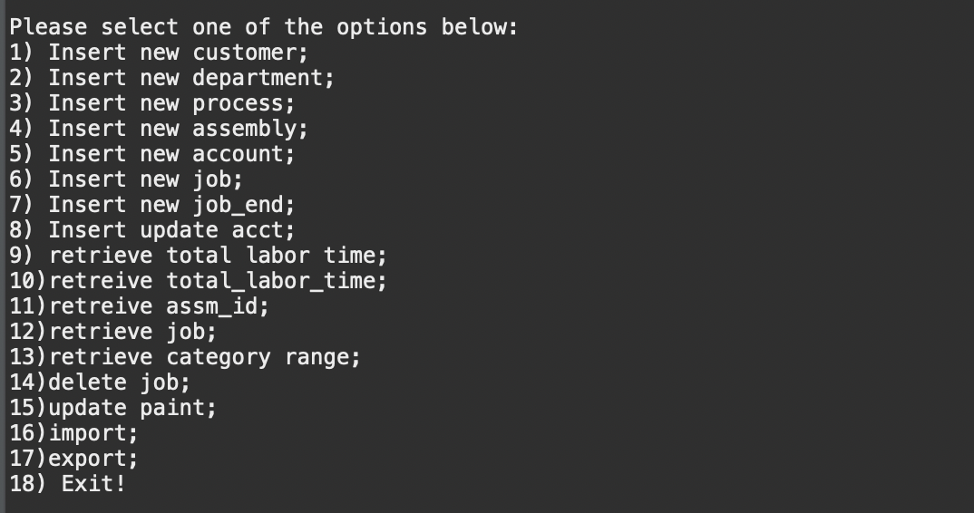

## 6.1. Screenshots showing testing of Query 1

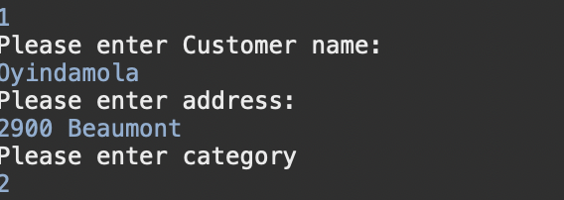

**Customer**

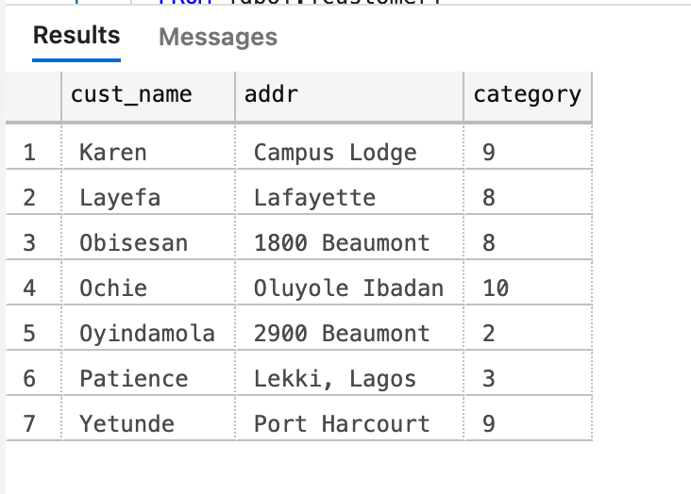

## 6.2. Screenshots showing testing of Query 1

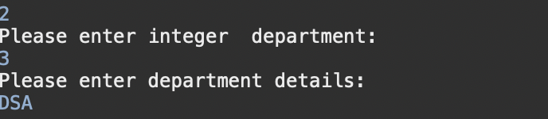

**Departments**

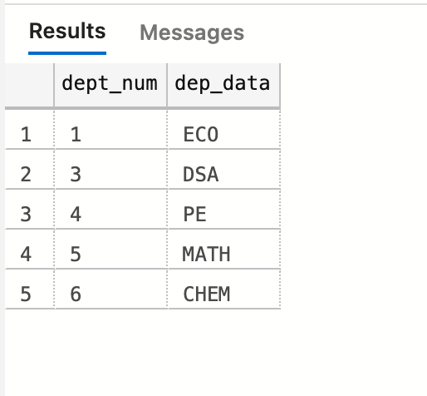

## 6.3. Screenshots showing testing of Query 3

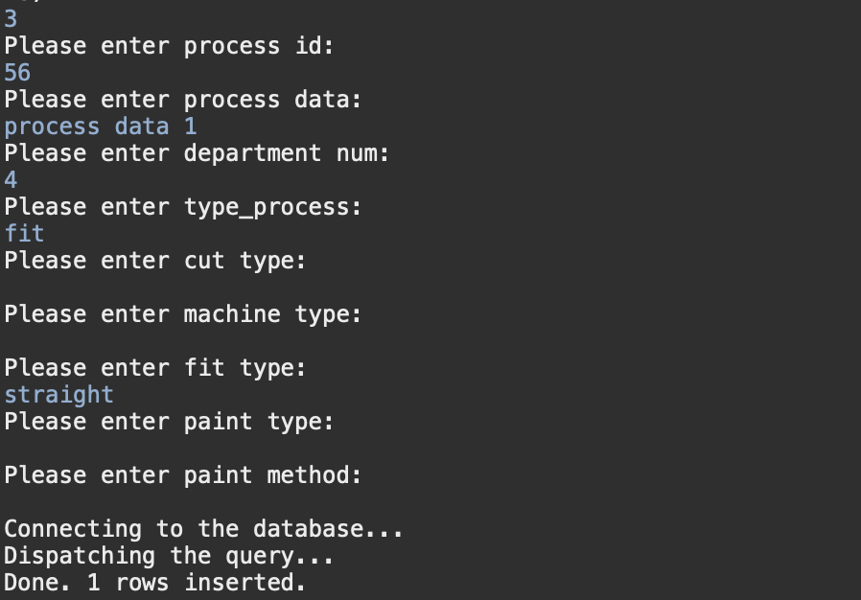

**Processes**

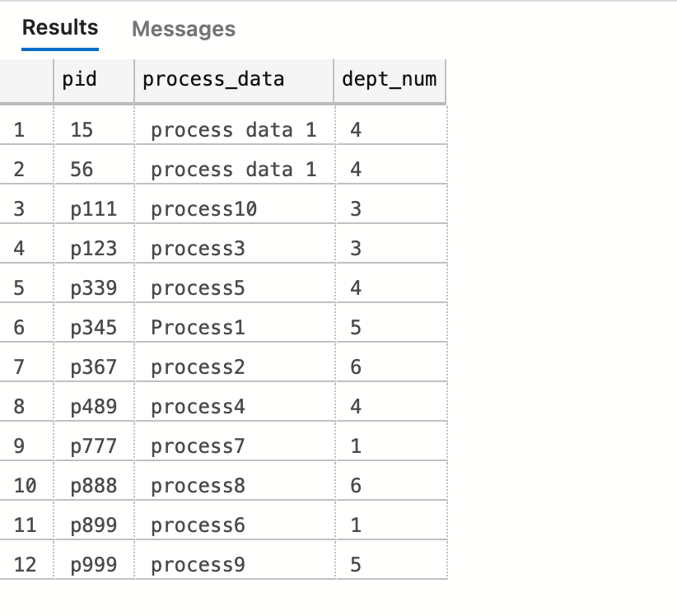

**Process_fit**

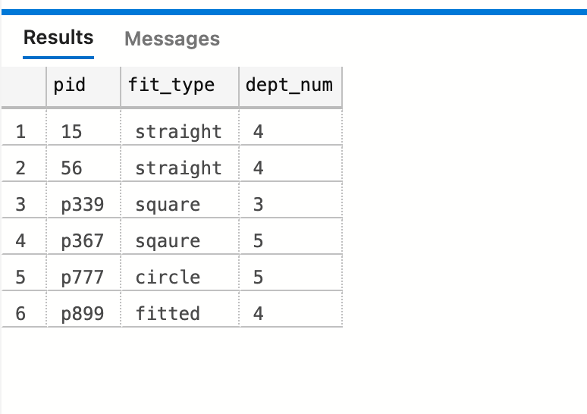

**Processes_paint**

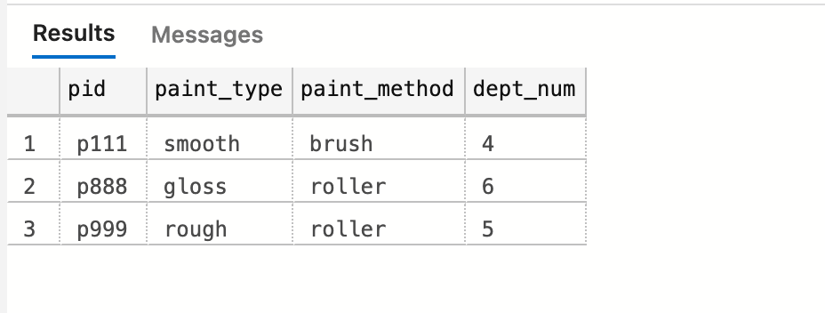

**Processes_cut**

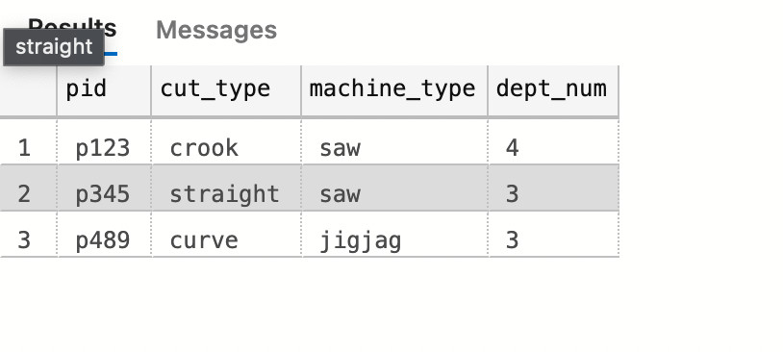

## 6.4. Screenshots showing testing of Query 4

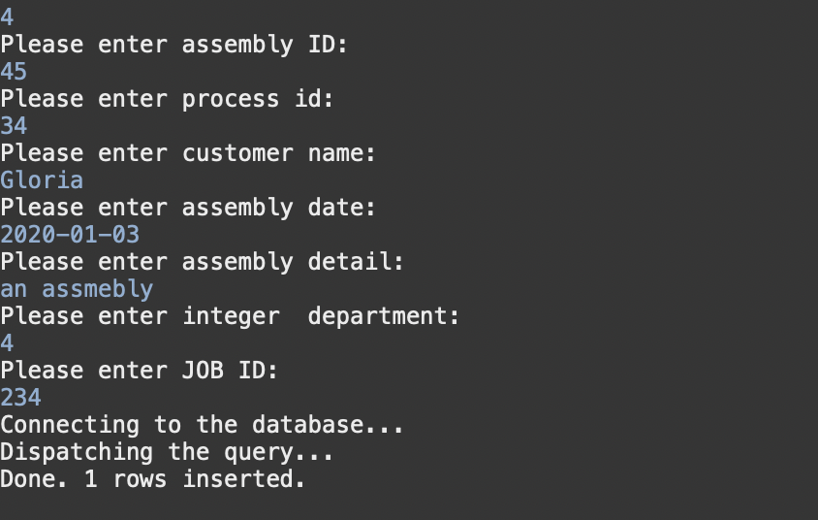

**Assemblies**

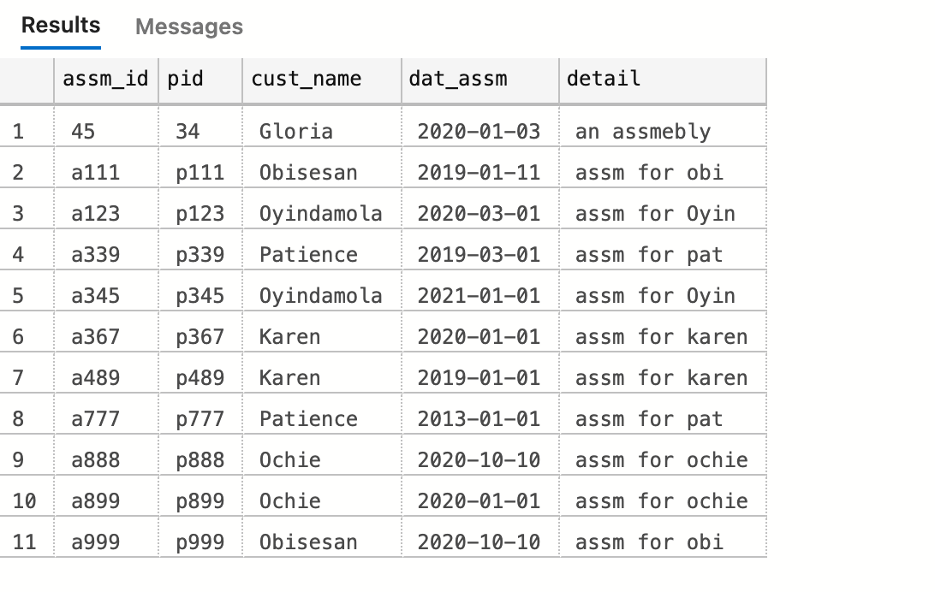

**Orders**

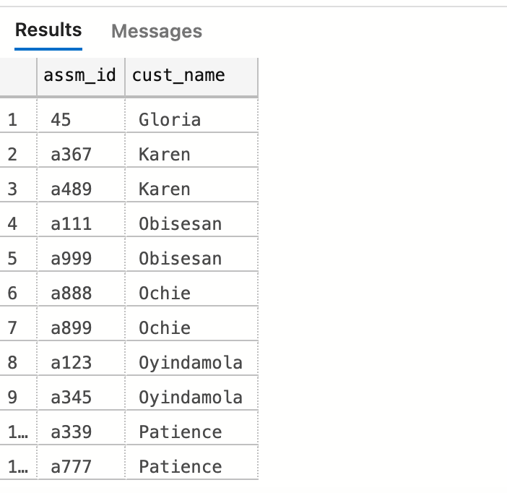

**Has**

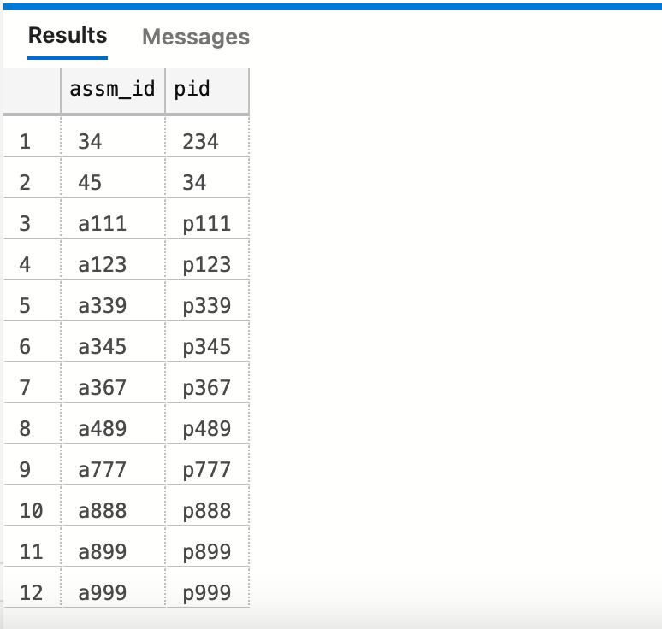

## 6.5. Screenshots showing testing of Query 5

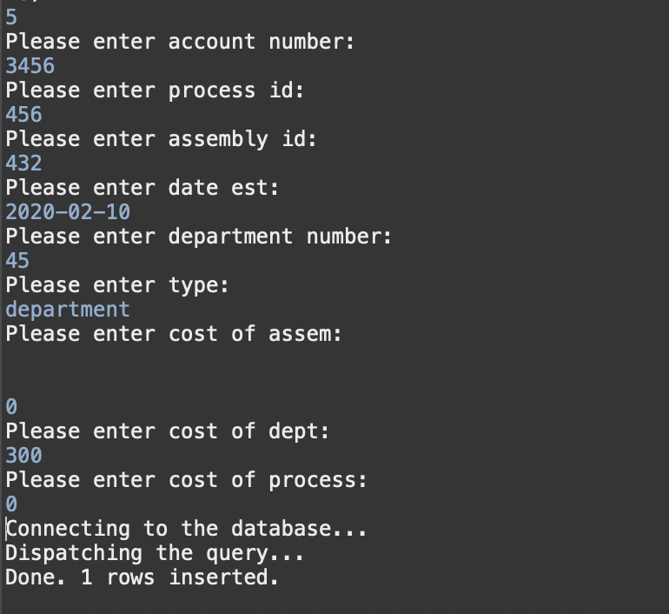

Acct_assm

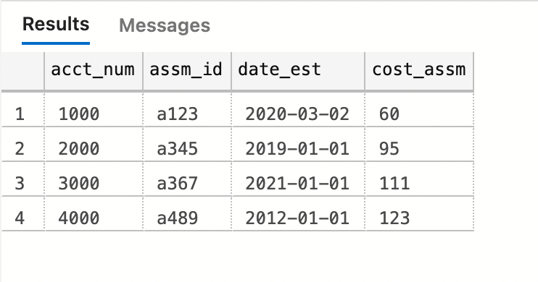

Acct_dep

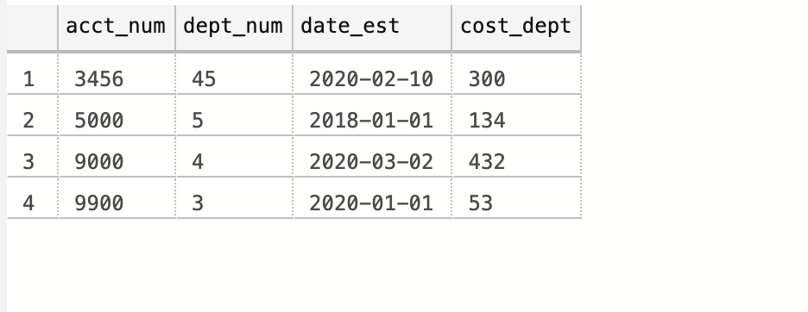

Acct_pro

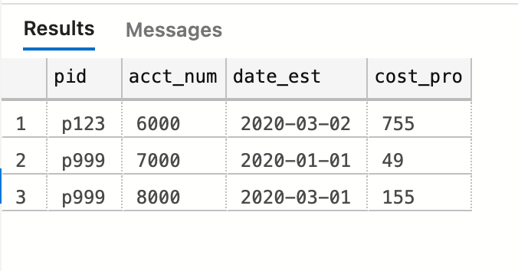

## 6.6. Screenshots showing testing of Query 6

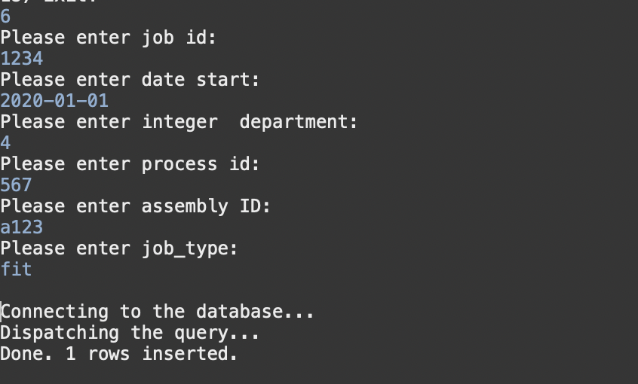

**done**

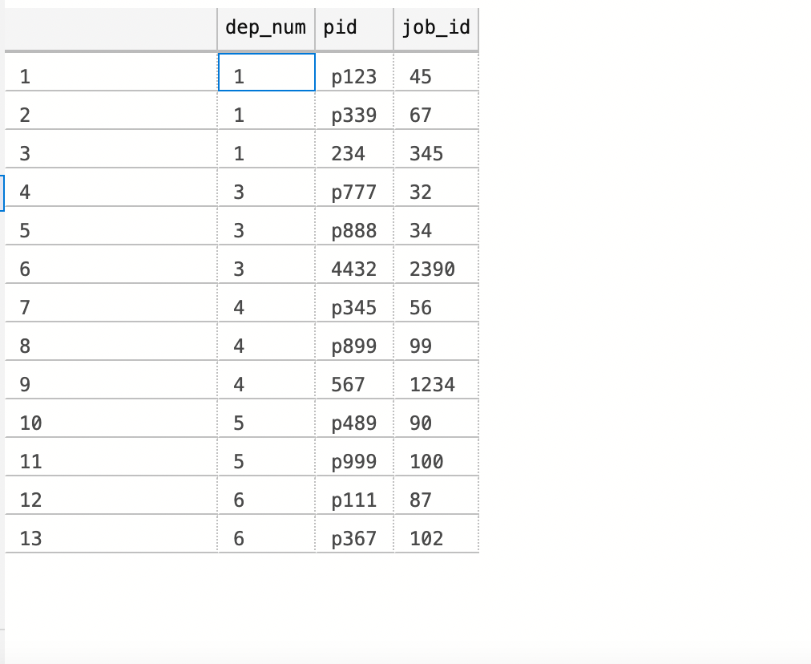

**Job_cut**

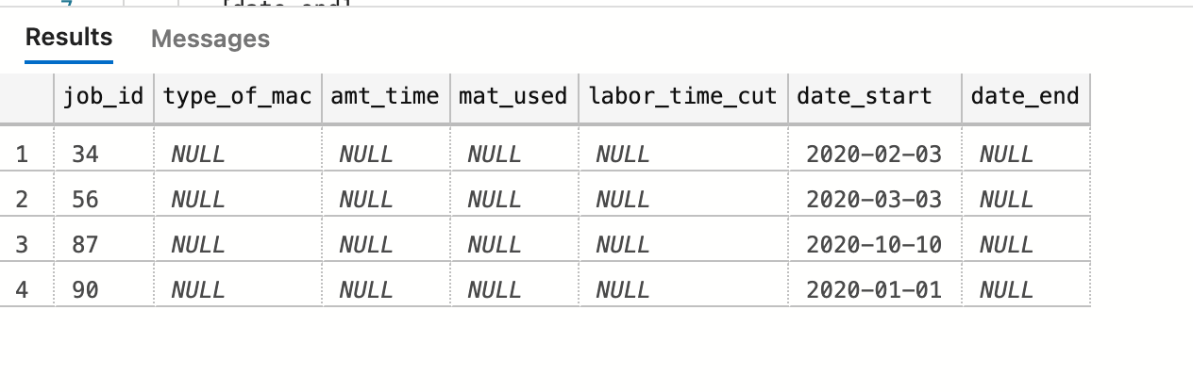

**Job_fit**

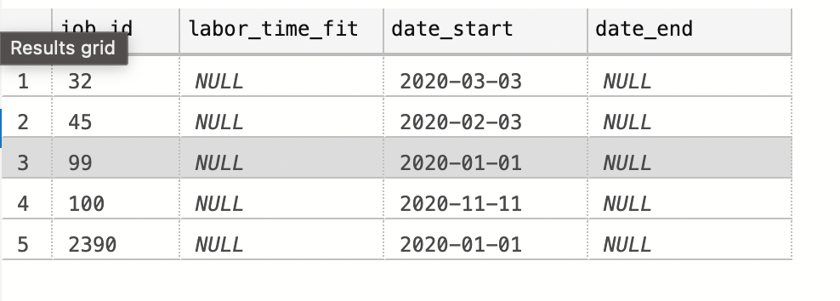

**Job_paint**

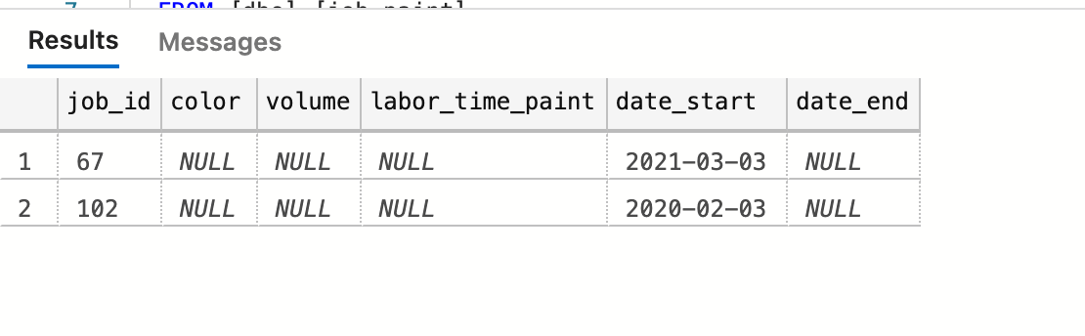

## 6.7. Screenshots showing testing of Query 7

**Job_cut**

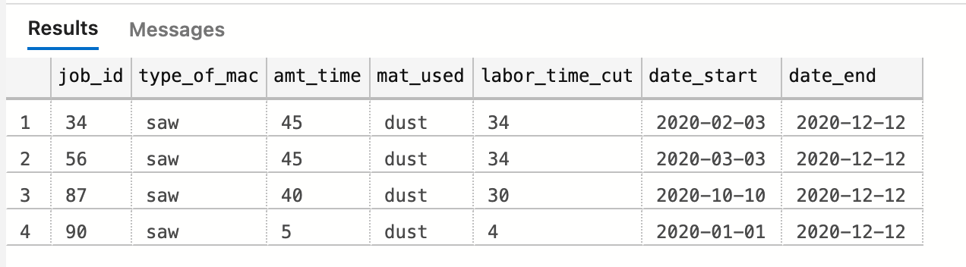

**Job_fit**

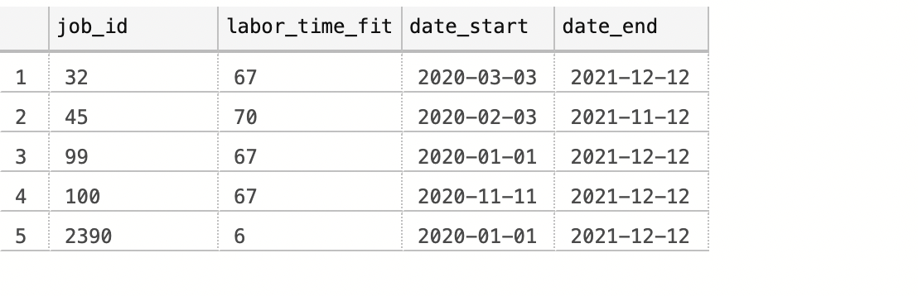

**Job_paint**

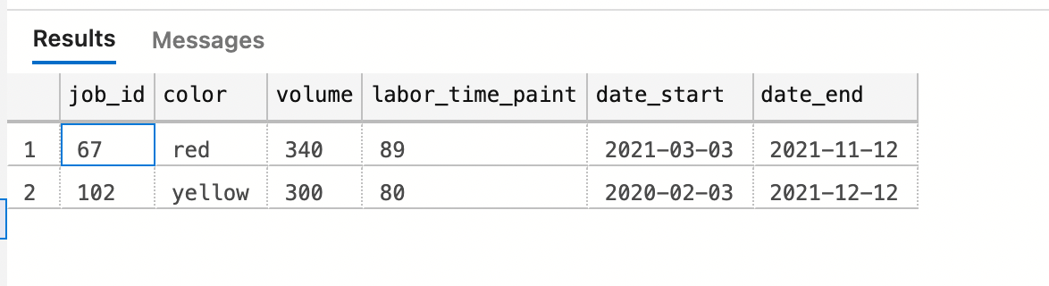

## 6.8. Screenshots showing testing of Query 8

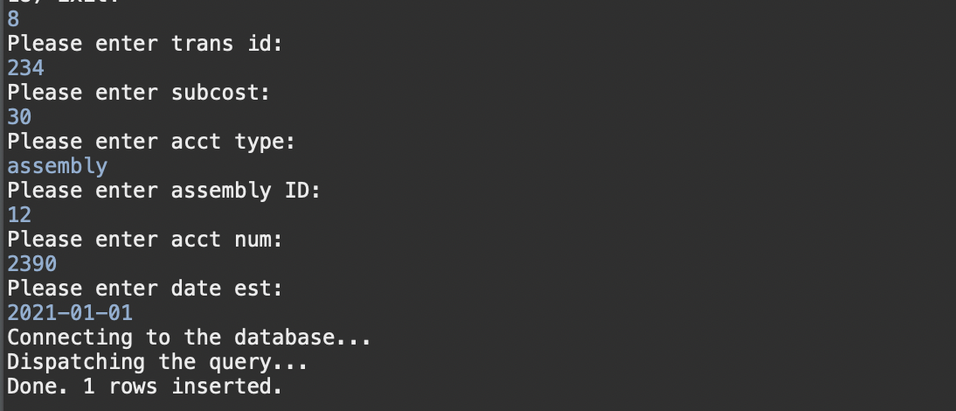

**Transactions**

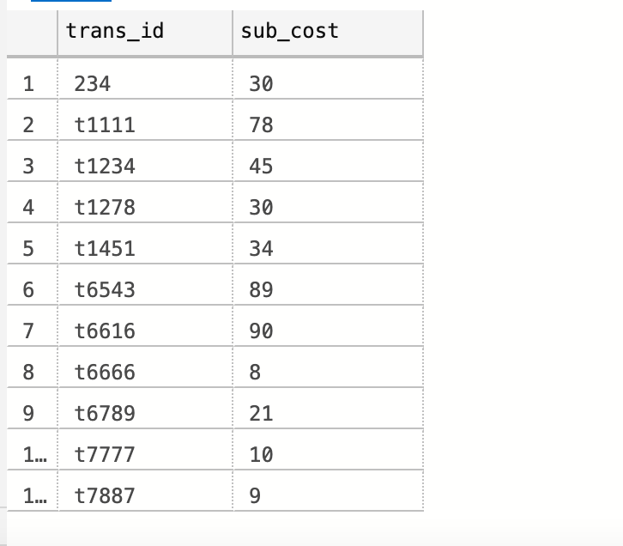

**Updates**

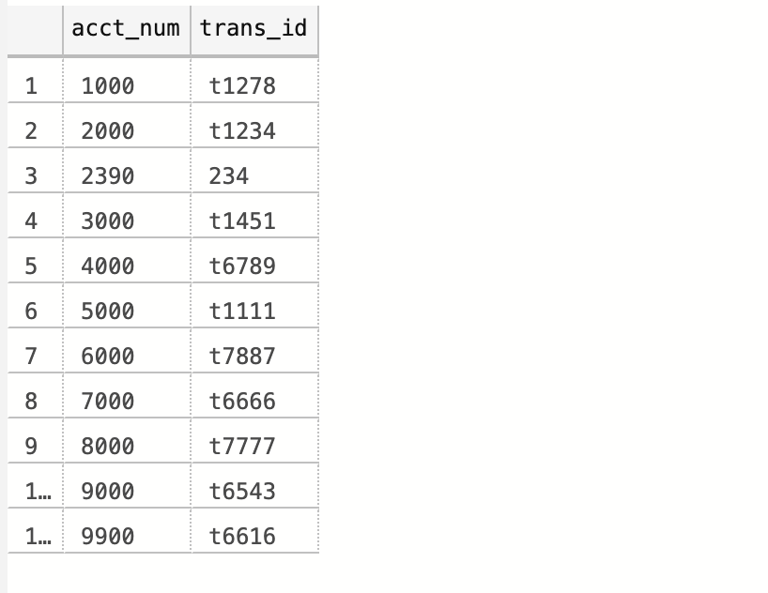

**Acct_assem**

Before:

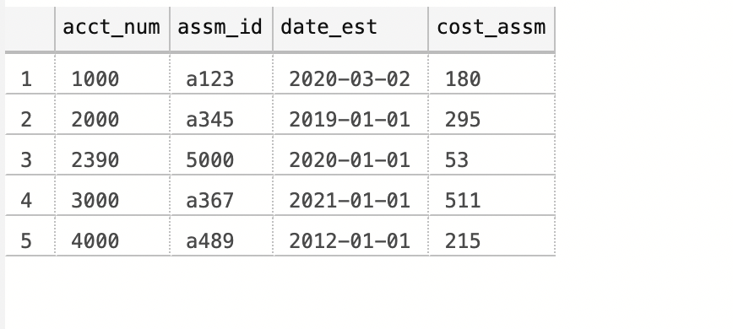

After

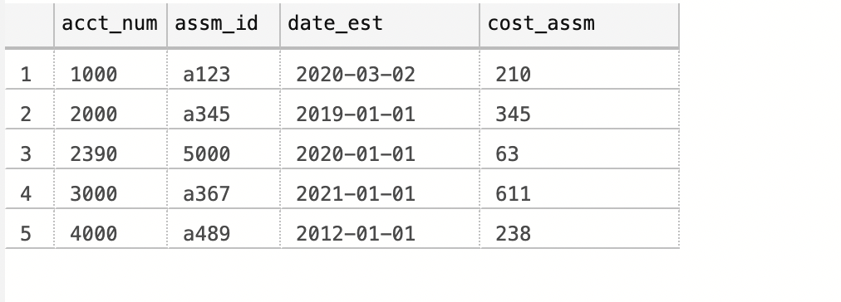

**Assem_pro**

Before

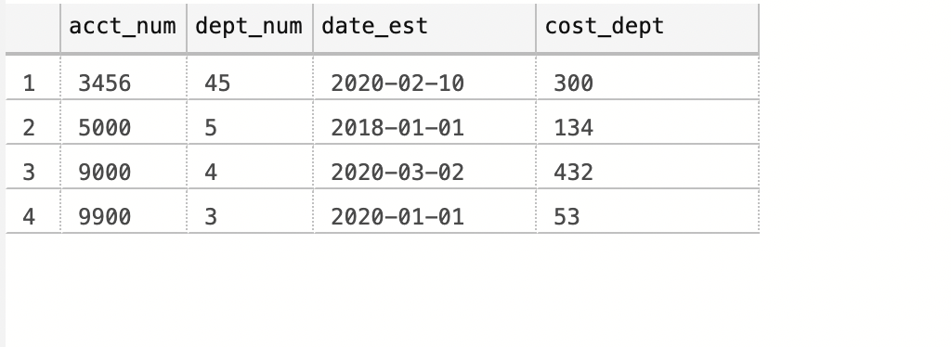

After

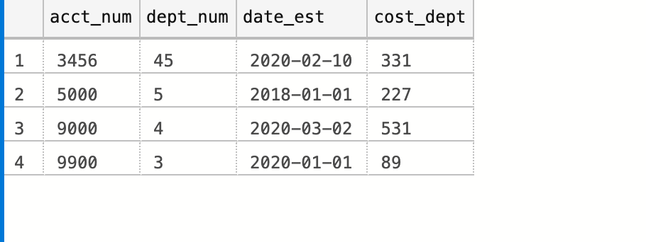

**Assm_pro**

Before

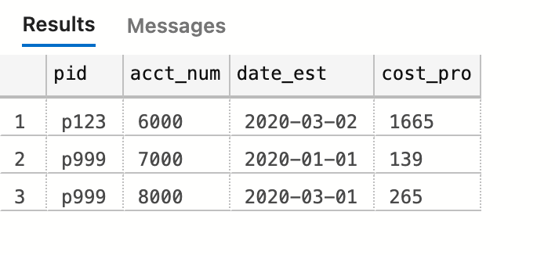

After

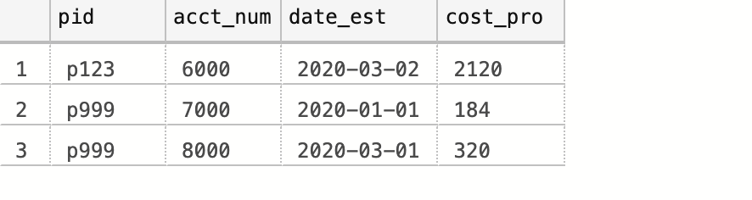

## 6.9. Screenshots showing testing of Query 9

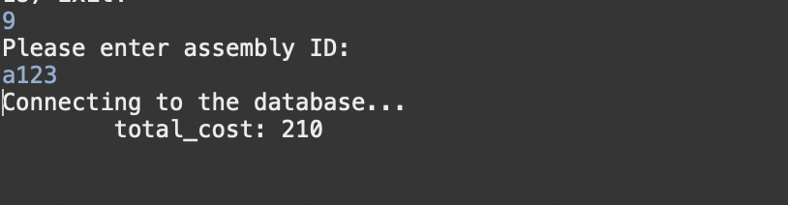

## 6.10. Screenshots showing testing of Query 10

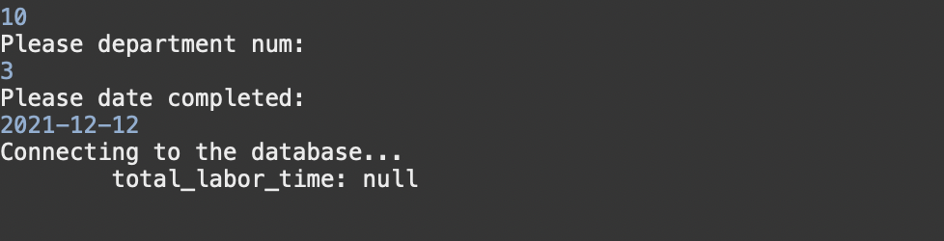

## 6.11. Screenshots showing testing of Query 11

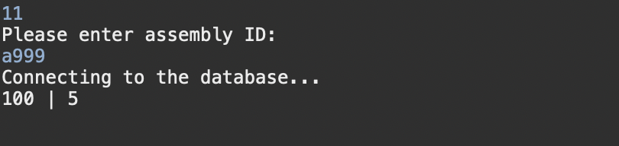

## 6.12. Screenshots showing testing of Query 12

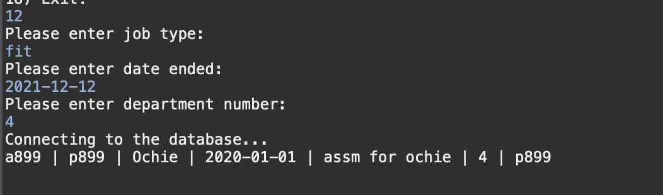

## 6.13. Screenshots showing testing of Query 13

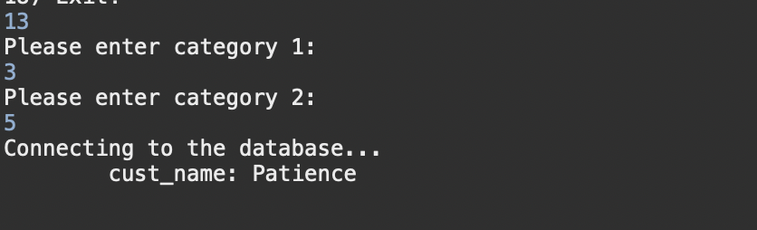

## 6.14. Screenshots showing testing of Query 14

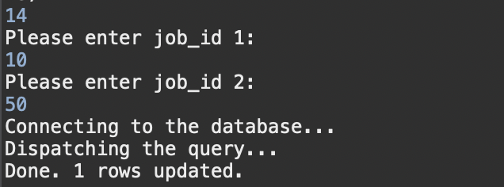

## 6.15. Screenshots showing testing of Query 15

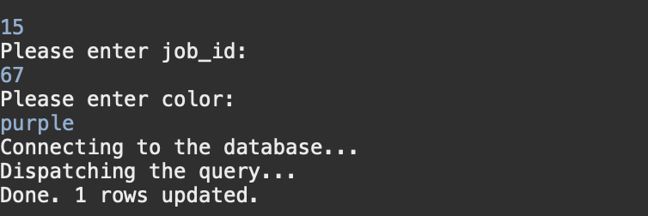

## 6.16. Screenshots showing testing of Query 16

**Import**

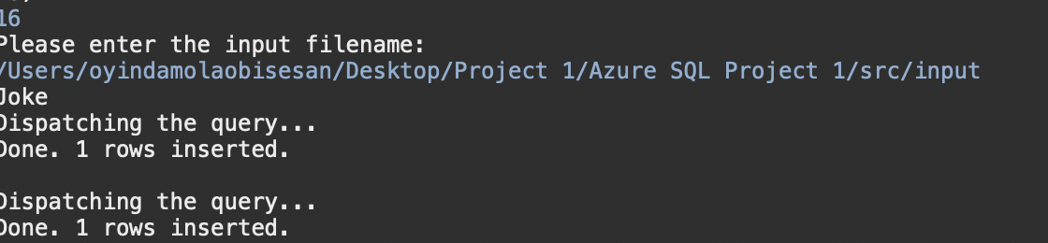

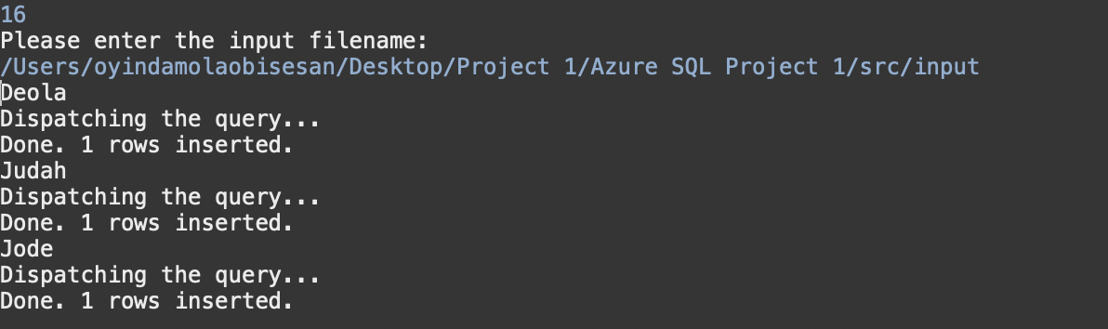

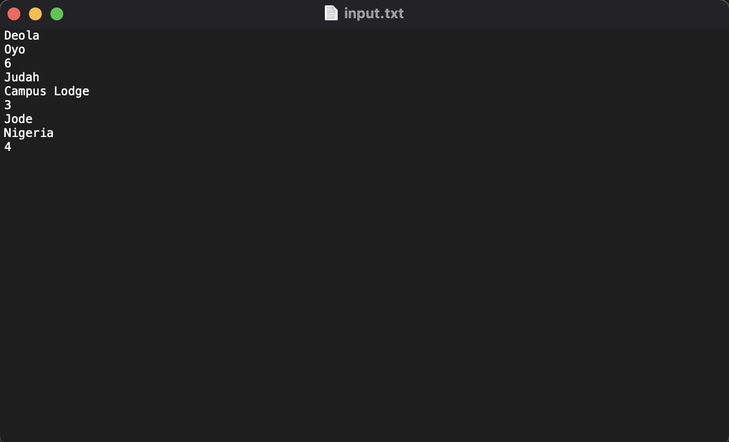

## 6.17. Screenshots showing testing of Query 17

**Export**

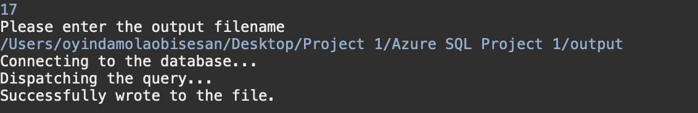

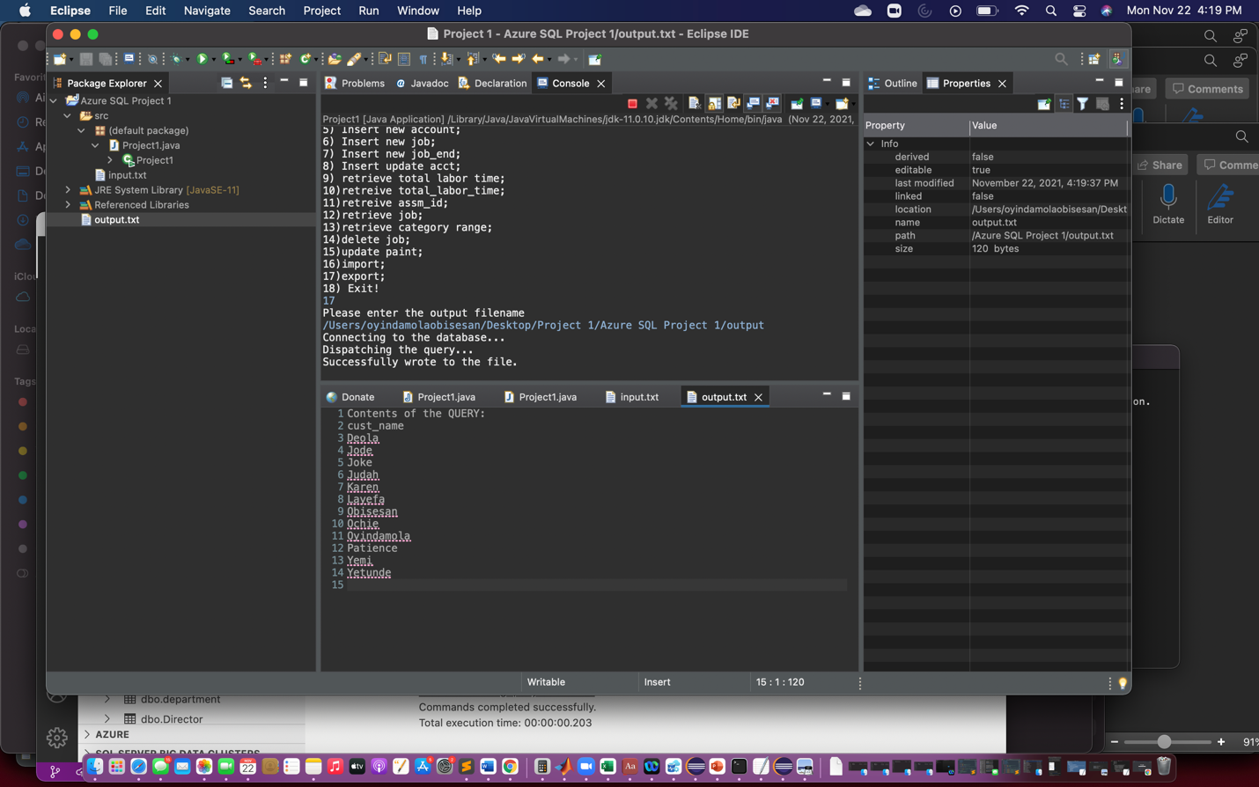

## 6.17. Screenshots showing testing of Query 17

**Quit**

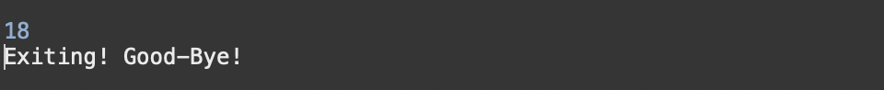

## **Errors in Azure database**

1. Category is an integer, and a string was supplied so it returned an error.

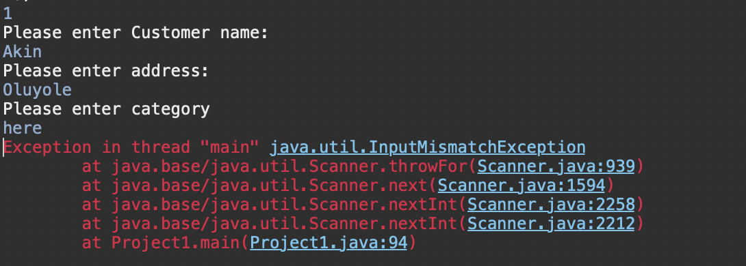

1. Department is an integer, and a float was supplied so it returned an error.

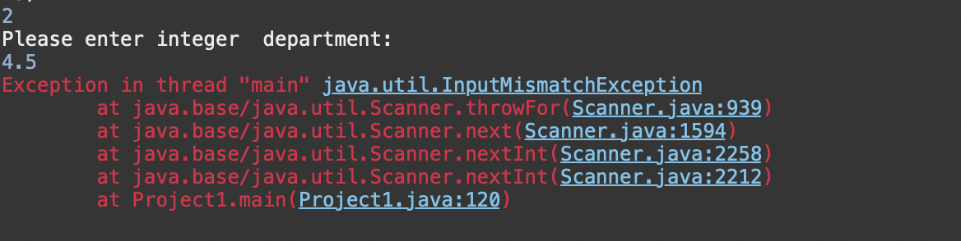

1. account is an integer, and a string was supplied so it returned an error.

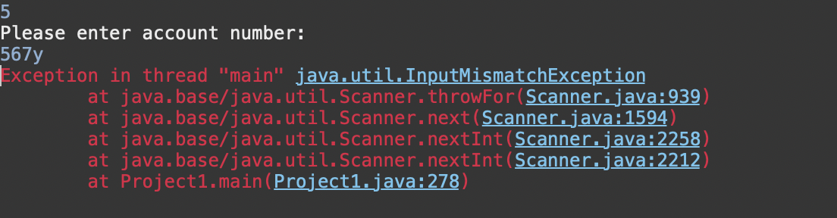

# Task 7 – Web Database and its execution

## 7.1. Web database application source code

**Datahandler**

package project_azure;

import java.sql.Connection;

import java.sql.ResultSet;

import java.sql.SQLException;

import java.sql.DriverManager;

import java.sql.PreparedStatement;

public class DataHandler {

private Connection conn;

// Azure SQL connection credentials

final static String ***host*** = "obis000-sql-server.database.windows.net";

final static String ***database*** = "cs-dsa-4513-sql-db";

final static String ***username*** = "obis0000";

final static String ***password*** = "Anec3030";

// Resulting connection string

final private String url =

String.*format*("jdbc:sqlserver://%s:1433;database=%s;user=%s;password=%s;encrypt=true;trustServerCertificate=false;hostNameInCertificate=*.database.windows.net;loginTimeout=30;",

***host***, ***database***, ***username***, ***password***);

// Initialize and save the database connection

private void getDBConnection() throws SQLException {

if (conn != null) {

return;

}

this.conn = DriverManager.*getConnection*(url);

}

// Return the result of selecting everything from the movie_night table

public ResultSet getAllcust() throws SQLException {

getDBConnection();

final String sqlQuery = "SELECT * FROM customer;";

final PreparedStatement stmt = conn.prepareStatement(sqlQuery);

return stmt.executeQuery();

}

// Inserts a record into the movie_night table with the given attribute values

public boolean addcustomer(

String cust_name, String addr, int category) throws SQLException {

getDBConnection(); // Prepare the database connection

// Prepare the SQL statement

final String sqlQuery =

"INSERT INTO customer " +

"(cust_name, addr, category) " +

"VALUES " +

"(?, ?, ?)";

final PreparedStatement stmt = conn.prepareStatement(sqlQuery);

// Replace the '?' in the above statement with the given attribute values

stmt.setString(1, cust_name);

stmt.setString(2, addr);

stmt.setInt(3, category);

// Execute the query, if only one record is updated, then we indicate success by returning true

return stmt.executeUpdate() == 1;

}

//public ResultSet somecustomer() throws SQLException {

public ResultSet somecustomer(int category_1, int category_2) throws SQLException {

getDBConnection(); // Prepare the database connection

// Prepare the SQL statement

final String sqlQuery =

"select cust_name " +

"from customer " +

"where category between ? and ? " +

"order by cust_name asc ";

System.***out***.println(category_1);

System.***out***.println(category_2);

final PreparedStatement stmt = conn.prepareStatement(sqlQuery);

// Replace the '?' in the above statement with the given attribute values

//stmt.setInt(1, category_1);

//stmt.setInt(2, category_2);

//stmt.setInt(3, category);

// Execute the query, if only one record is updated, then we indicate success by returning true

return stmt.executeQuery();

}

}

**Query 1**

**Get_all customers**

<%@ **page** language=*"java"* contentType=*"text/html; charset=UTF-8"*

pageEncoding=*"UTF-8"*%>

<!**DOCTYPE** html>

<**html**>

<**head**>

<**meta** charset=*"UTF-8"*>

<**title**>Customer</**title**>

</**head**>

<**body**>

<%@**page** import=*"project_azure.DataHandler"*%>

<%@**page** import=*"java.sql.ResultSet"*%>

<%

// We instantiate the data handler here, and get all the customer from the database

final DataHandler handler = new DataHandler();

final ResultSet customer = handler.getAllcust();

%>

<!-- The table for displaying all the customer records -->

<**table** cellspacing=*"2"* cellpadding=*"2"* border=*"1"*>

<**tr**> <!-- The table headers row -->

<**td** align=*"center"*>

<**h4**>cust_name</**h4**>

</**td**>

<**td** align=*"center"*>

<**h4**>addr</**h4**>

</**td**>

<**td** align=*"center"*>

<**h4**>category</**h4**>

</**td**>

</**tr**>

<%

while(customer.next()) { // For each customer record returned...

// Extract the attribute values for every row returned

final String cust_name = customer.getString("cust_name");

final String addr = customer.getString("addr");

final String category = customer.getString("category");

out.println("<tr>"); // Start printing out the new table row

out.println( // Print each attribute value

"<td align=\"center\">" + cust_name +

"</td><td align=\"center\"> " + addr +

"</td><td align=\"center\"> " + category + "</td>");

out.println("</tr>");

}

%>

</**table**>

</**body**>

</**html**>

Add_cust

<%@ **page** language=*"java"* contentType=*"text/html; charset=UTF-8"*

pageEncoding=*"UTF-8"*%>

<!**DOCTYPE** html PUBLIC "-//W3C//DTD HTML 4.01 Transitional//EN"

"http://www.w3.org/TR/html4/loose.dtd">

<**html**>

<**head**>

<**meta** http-equiv=*"Content-Type"* content=*"text/html; charset=UTF-8"*>

<**title**>Query Result</**title**>

</**head**>

<**body**>

<%@**page** import=*"project_azure.DataHandler"*%>

<%@**page** import=*"java.sql.ResultSet"*%>

<%@**page** import=*"java.sql.Array"*%>

<%

// The handler is the one in charge of establishing the connection.

DataHandler handler = new DataHandler();

// Get the attribute values passed from the input form.

String cust_name = request.getParameter("cust_name");

String address = request.getParameter("addr");

String categoryString = request.getParameter("category");

/*

* If the user hasn't filled out all the time, movie name and duration. This is very simple checking.

*/

if (cust_name.equals("") || address.equals("") || categoryString.equals("")) {

response.sendRedirect("add_cust_form.jsp");

} else {

int category = Integer.parseInt(categoryString);

// Now perform the query with the data from the form.

boolean success = handler.addcustomer(cust_name, address, category);

if (!success) { // Something went wrong

%>

<**h2**>There was a problem inserting the course</**h2**>

<%

} else { // Confirm success to the user

%>

<**h2**>The Customer:</**h2**>

<**ul**>

<**li**>cust_name: <%=cust_name%></**li**>

<**li**>address: <%=address%></**li**>

<**li**>category: <%=categoryString%></**li**>

</**ul**>

<**h2**>Was successfully inserted.</**h2**>

<**a** href=*"get_all_cust.jsp"*>See all customers.</**a**>

<%

}

}

%>

</**body**>

</**html**>

**Add_cust_form**

<!**DOCTYPE** html>

<**html**>

<**head**>

<**meta** charset=*"UTF-8"*>

<**title**>Add Customer</**title**>

</**head**>

<**body**>

<**h2**>Add Customer</**h2**>

<!--

Form for collecting user input for the new movie_night record.

Upon form submission, add_movie.jsp file will be invoked.

-->

<**form** action=*"add_cust.jsp"*>

<!-- The form organized in an HTML table for better clarity. -->

<**table** border=*1*>

<**tr**>

<**th** colspan=*"2"*>Enter the customer Data:</**th**>

</**tr**>

<**tr**>

<**td**>Customer Name:</**td**>

<**td**><**div** style="text-align: *center*;">

<**input** type=*text* name=*cust_name*>

</**div**></**td**>

</**tr**>

<**tr**>

<**td**>Address:</**td**>

<**td**><**div** style="text-align: *center*;">

<**input** type=*text* name=*addr*>

</**div**></**td**>

</**tr**>

<**tr**>

<**td**>Category:</**td**>

<**td**><**div** style="text-align: *center*;">

<**input** type=*text* name=*category*>

</**div**></**td**>

</**tr**>

<**tr**>

<**td**><**div** style="text-align: *center*;">

<**input** type=*reset* value=*Clear*>

</**div**></**td**>

<**td**><**div** style="text-align: *center*;">

<**input** type=*submit* value=*Insert*>

</**div**></**td**>

</**tr**>

</**table**>

</**form**>

</**body**>

</**html**>

**For getting customer within a range – query 13**

**Get_some_cust (form)**

<!**DOCTYPE** html>

<**html**>

<**head**>

<**meta** charset=*"UTF-8"*>

<**title**>Get Customer</**title**>

</**head**>

<**body**>

<**h2**>Get Customer</**h2**>

<!--

Form for collecting user input for the new customer record.

Upon form submission, cust_some_.jsp file will be invoked.

-->

<**form** action=*"cust_some.jsp"*>

<!-- The form organized in an HTML table for better clarity. -->

<**table** border=*1*>

<**tr**>

<**th** colspan=*"2"*>Enter the customer Data:</**th**>

</**tr**>

<**tr**>

<**td**>Category_1:</**td**>

<**td**><**div** style="text-align: *center*;">

<**input** type=*text* name=*category_1*>

</**div**></**td**>

</**tr**>

<**tr**>

<**td**>Category_2:</**td**>

<**td**><**div** style="text-align: *center*;">

<**input** type=*text* name=*category_2*>

</**div**></**td**>

</**tr**>

<**tr**>

<**td**><**div** style="text-align: *center*;">

<**input** type=*reset* value=*Clear*>

</**div**></**td**>

<**td**><**div** style="text-align: *center*;">

<**input** type=*submit* value=*Insert*>

</**div**></**td**>

</**tr**>

</**table**>

</**form**>

</**body**>

</**html**>

Cust_some

<%@ **page** language=*"java"* contentType=*"text/html; charset=UTF-8"*

pageEncoding=*"UTF-8"*%>

<!**DOCTYPE** html PUBLIC "-//W3C//DTD HTML 4.01 Transitional//EN"

"http://www.w3.org/TR/html4/loose.dtd">

<**html**>

<**head**>

<**meta** http-equiv=*"Content-Type"* content=*"text/html; charset=UTF-8"*>

<**title**>Query Result</**title**>

</**head**>

<**body**>

<%@**page** import=*"project_azure.DataHandler"*%>

<%@**page** import=*"java.sql.ResultSet"*%>

<%@**page** import=*"java.sql.Array"*%>

<%

// The handler is the one in charge of establishing the connection.

final DataHandler handler = new DataHandler();

// Get the attribute values passed from the input form.

//String cust_name = request.getParameter("cust_name");

//String address = request.getParameter("addr");

String categoryString_1 = request.getParameter("category_1");

String categoryString_2 = request.getParameter("category_2");

/*

* If the user hasn't filled out all the time, movie name and duration. This is very simple checking.

*/

if (categoryString_1.equals("") || categoryString_2.equals("")) {

response.sendRedirect("get_some_cust.jsp");

}

else {

int category_1 = Integer.parseInt(categoryString_1);

int category_2 = Integer.parseInt(categoryString_2);

// Now perform the query with the data from the form.

//boolean success = handler.somecustomer(category_1, category_2);

//if (!success) { // Something went wrong

// } else { // Confirm success to the user

%>

<**h2**>The Customers:</**h2**>

<**ul**>

<**li**>category: <%=categoryString_1%></**li**>

<**li**>category: <%=categoryString_2%></**li**>

</**ul**>

<**h2**>customers were retrieved.</**h2**>

<**a** href=*"get_all_cust.jsp"*>See all customers.</**a**>

<%

//final DataHandler handler = new DataHandler();

final ResultSet customer = handler.somecustomer(category_1, category_2);

// final ResultSet customer = handler.somecustomer(category_1, category_2);

%>

<!-- The table for displaying all the movie records -->

<**table** cellspacing=*"2"* cellpadding=*"2"* border=*"1"*>

<**tr**> <!-- The table headers row -->

<**td** align=*"center"*>

<**h4**>cust_name</**h4**>

</**td**>

</**tr**>

<%

while(customer.next()) { // For each movie_night record returned...

// Extract the attribute values for every row returned

final String cust_name = customer.getString("cust_name");

out.println("<tr>"); // Start printing out the new table row

out.println( // Print each attribute value

"<td align=\"center\">" + cust_name + "</td>");

out.println("</tr>");

}

}

%>

</**body**>

</**html**>

## 7.2. screenshots showing the testing of the web database application

**Query 13;**

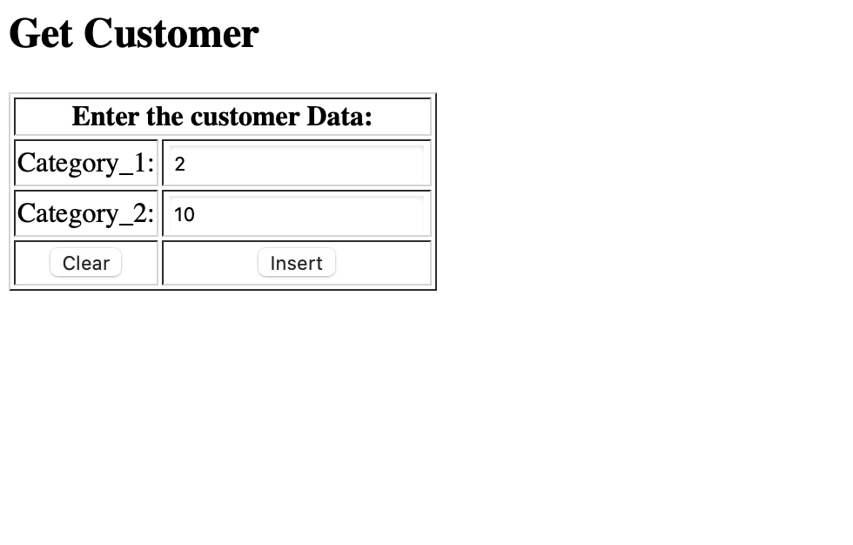

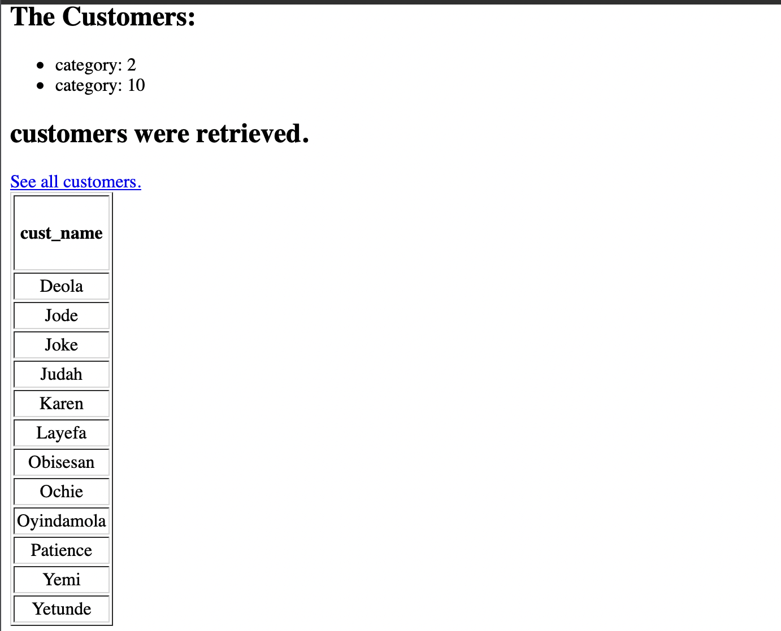

**Query 1;**

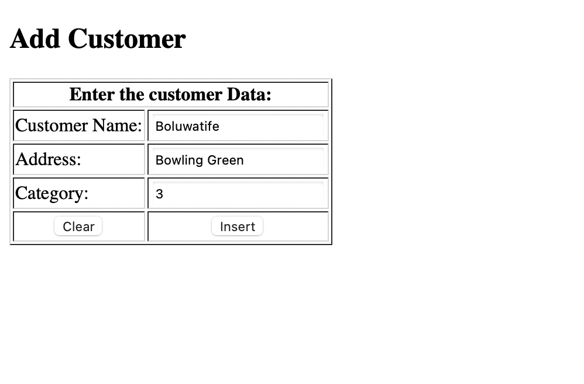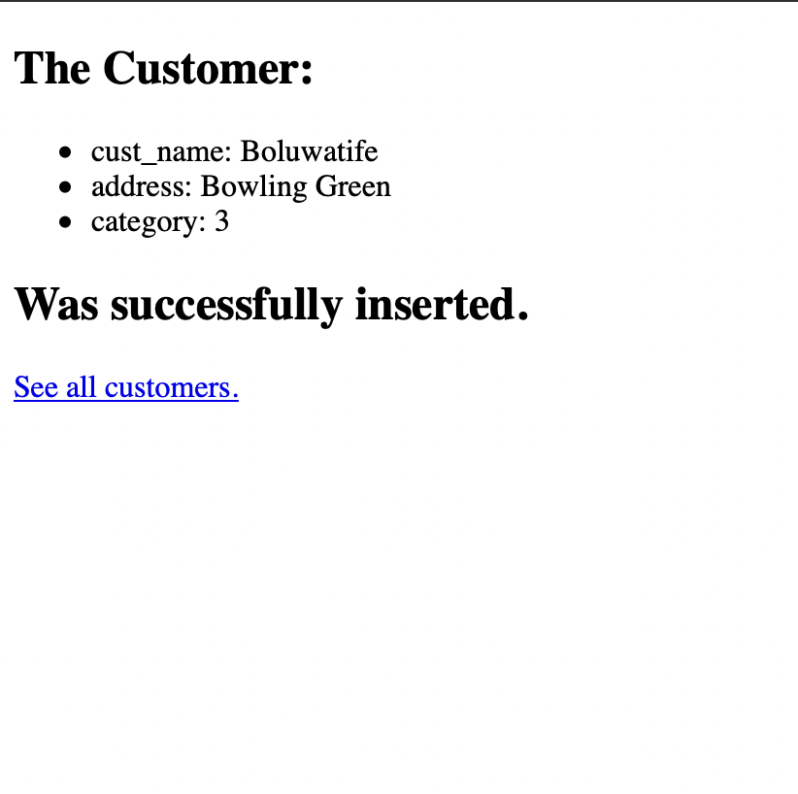

**Query 13 – re run**



